**Sustainable Energy Academy – Module 3 Draft**

UNDP Sustainable Energy Hub

# Module 3: Energy and Sustainable Development Nexus

**Module overview:** The urgency to address climate change and achieve the 2030 agenda, coupled with the complexity and interconnectedness of today's global landscape, demands integrated approaches. Global patterns and emerging insights highlight the power of SDG combinations in accelerating progress amidst multifaceted development challenges (SDG Push). Integrated development solutions are required, leveraging synergies and mitigating trade-offs to enhance structural transformations, building resilience while leaving no one behind. However, solutions are not one-size-fits-all; they demand tailored approaches aligned with national priorities. This module aims to empower participants as change-makers and leaders in innovative sustainable development solutions, fostering multiple SDG achievements within energy initiatives. It explores intricate interlinkages between sustainable energy and various SDGs, offering methodological approaches and implementation strategies. Chapter 1 elucidates the complex relationship between energy access and clean cooking (SDG 7.1), renewable energy (SDG 7.2) and energy efficiency (SDG 7.3) and other SDGs. Chapter 2 delves into tools, approaches, and methods for strategic innovation, enabling integrated solutions for multiple challenges. Chapter 3 presents a roadmap for development financing, focusing on the role of partnerships and collaboration in fostering these integrated development solutions.

**Module Learning Objectives:**

* Learners will gain a comprehensive understanding of how sustainable energy intertwines with other SDGs, exploring opportunities and navigating challenges to create impactful solutions through synergies and trade-offs.
* Participants will develop a robust foundation in key approaches, methodologies, and tools across the sustainable energy initiative cycle, reinforcing systemic strategies to operationalize the achievement of multiple SDGs.
* Attendees will explore the evolving landscape of partnerships and financial structures for SDG interlinkage, uncovering actionable strategies to drive change by fostering collaboration and leveraging innovative financing mechanisms.
* Enrollees will engage with real-world case studies and practical applications, revealing the transformative potential of systemic change, and gaining insights into sustainable and holistic development strategies involving collaboration and partnerships.
* Participants will cultivate critical thinking, operationalize innovative methods, and leverage newfound knowledge in partnerships and collaboration, propelling them to lead strategic innovations and emerge as impactful change-makers toward sustainable energy and multiple signature solutions

[Module 3: Energy and Sustainable Development Nexus 1](#_Toc2004884317)

[1. Interlinkages between Energy and other SDGs 2](#_Toc732947285)

[1.1. SDG 7.1 Access to electricity and clean cooking 4](#_Toc1481478131)

[1.1.1. Maximizing Synergies in Sustainable Energy Access 5](#_Toc496045724)

[1.1.2. Overcoming Energy Access Trade-offs 8](#_Toc872940681)

[1.2. SDG 7.2 Renewable energy 10](#_Toc750344084)

[1.2.1. Advancing Sustainable Prosperity with Renewable Energy 11](#_Toc1115890512)

[1.2.2. Managing Trade-offs in Renewable Energy for Sustainable Development 13](#_Toc1445080014)

[1.3. SDG 7.3 Energy efficiency 15](#_Toc1140219272)

[1.3.1. Catalyzing Sustainability through Energy Efficiency 16](#_Toc841976346)

[1.3.2. Developing Informed Strategies for Energy Efficiency Trade-offs 18](#_Toc138907089)

[2. Approaches, Methods and Tools for Strategic Innovation 20](#_Toc1018914649)

[2.1. Approaches 21](#_Toc1513416730)

[2.1.1. System Thinking Approach 21](#_Toc1075523599)

[2.1.2. Gender Mainstreaming 22](#_Toc1063063054)

[2.1.3. Human Rights-Based Approach 24](#_Toc120882684)

[2.1.4. Portfolio Approach 26](#_Toc489293566)

[2.2. Methods and Tools 28](#_Toc1120139324)

[2.2.1. The Water-Energy-Food-Ecosystem Nexus 28](#_Toc884028868)

[2.2.2. Life Cycle Assessment 30](#_Toc1737127116)

[2.2.3. Multi-Criteria Decision Analysis frameworks 31](#_Toc2142657988)

[2.2.4. Scenario Thinking: 31](#_Toc973310766)

[2.2.5. Theory of Change 32](#_Toc972681756)

[2.2.6. Digital Intelligence: Machine Learning, Deep Learning and Artificial Intelligence 32](#_Toc1367006142)

[3. Partnership and Collaboration for Development Financing 33](#_Toc859816034)

[3.1. Partnership Ecosystems for Sustainable Energy and Integrated SDGs 34](#_Toc649623332)

[3.1.1. Compacts, Coalitions, Alliances, Hubs and Public-Private Partnerships 35](#_Toc600228432)

[3.1.2. Joint Programs and Inter-agencies Initiatives 38](#_Toc332937762)

[3.1.3. Multi-Stakeholders Knowledge and Data Platforms 39](#_Toc1192746359)

[3.2. Establishing Effective Partnerships and Collaboration 41](#_Toc624600921)

[3.2.1. Building and Managing Effective Multi-Stakeholder Partnerships for SDG Progress 41](#_Toc1673356340)

[3.2.2. Developing Joint Programs 43](#_Toc775593924)

[3.3. Financial Mechanism for Integrated SDGs Achievement 45](#_Toc7119228)

[3.3.1. The Collaborative Financial Landscape 46](#_Toc606581467)

[3.3.2. Emerging Financial Solutions and Opportunities 47](#_Toc547571960)

[3.3.3. Financing Frameworks, Platforms and Tools 49](#_Toc695711338)

[Module Warp-Up 54](#_Toc2056367789)

[Main take-home messages 54](#_Toc556166343)

[What next? 55](#_Toc1114439960)

[References 55](#_Toc1271832706)

## Interlinkages between Energy and other SDGs

Since the 2030 Agenda for Sustainable Development was conceived to be integrated and indivisible, the SDGs are interlinked and interdependent by design. Hence, SDG Interlinkages refer to the complex network of interconnections among goals, targets and indicators. Actions toward one SDG can have positive or negative impacts on others, varying across geographical and temporal scales. Understanding this complexity and the directionality of change is key for achieving the Agenda while safeguarding against unintended SDG deterioration (JCR Website). This approach facilitates the creation of integrated solutions that drive simultaneous progress across multiple SDGs by maximizing synergies and minimizing trade-offs, which aids in optimizing resources and accelerating response times.

UNDP's Strategic Plan 2022-2025 embraces integrated development solutions, grounded in a "3x6x3" framework. This comprehensive structure encompasses three Directions of Change—structural transformation, leaving no one behind, and building resilience—guiding systemic transformations beyond 2025. Within this framework, UNDP focuses on six Signature Solutions: poverty and inequality, gender equality, energy, environment, resilience, and governance, each aimed at addressing specific challenges and fostering sustainable development. Additionally, three Enablers—digitalization, strategic innovation, and development financing—work synergistically to maximize development impact, supporting inclusive, ethical, and sustainable societies while aligning capital flows with the SDGs, for scaled-up finance mobilization.

Understanding the interlinkages between Sustainable Energy for Development and the SDGs facilitates the creation of strategies addressing multiple Signature Solutions. By leveraging synergies and circumventing trade-offs, the impact is maximized toward the Directions of Change while optimizing budgets. Diverse tools aid decision-makers in identifying these connections, employing visual mapping methods to illustrate interlinkages among different SDGs, showcasing both positive and negative causal relations. Examples of such tools include the **JRC SDG Interlinkages Tool**, the **SDG Interlinkages Analysis & Visualization Tool** or the **UNESCAP Methodology for the integration of SDGs into National Planning**. While these tools consolidate available data into valuable insights, bridging the data gap remains a priority and a key strategy for holistic integrated development solutions targeting SDG interlinkages. Notably, data collected at the national level can drive inclusive energy transitions policies shaped by local contexts and realities. Anchoring solutions in comprehensive and inclusive data prevents the exacerbation of existing inequalities, with digital solutions emerging as strategic enablers that span diverse Signature Solutions for sustainable development.

**Tools for SDGs interlinkage visualization:**

**JRC SDG Interlinkages Tool**: Developed by the SDG team at the Joint Research Centre (JRC), this tool comprehensively assesses the interconnectedness within the 2030 Agenda for Sustainable Development. It relies on a meticulous methodology involving extensive literature reviews, curating a database from 92 selected publications since the adoption of the 2030 Agenda in 2015. The database meticulously documents clear interlinkages between different SDG goals, targets, or indicators, aiding policymakers by providing crucial insights to navigate and anticipate interactions among SDGs. This tool presents interlinkages at goal and target levels and offers advanced search capabilities for specific regions, methods of analysis, and directionalities.

**SDG Interlinkages Analysis & Visualization Tool**: Developed by the Institute for Global Environmental Strategies, this interactive tool presents causal relationships between relevant SDG targets for 27 countries in Asia and Africa. It utilizes statistical analysis of time-series data for indicators, enhancing network analysis techniques to showcase potential synergies and trade-offs between the SDG targets. Country-specific dashboards offer insights into the structure of interlinkages networks from a systemic perspective, aiding in understanding the dynamics between SDGs at a granular level.

**UNESCAP Methodology for the integration of SDGs into National Planning**: Developed by UNESCAP, this methodology facilitates the analysis of interlinkages between SDGs using a system thinking approach. Launched in 2016, it focuses on understanding and analyzing the directionality and strength of interlinkages within and across specific SDG targets. Utilizing causal loop diagrams, it highlights positive and reinforcing relationships between interlinked SDG targets, aiding in synchronized and integrated SDG implementation planning. The tool focuses on Asia and the Pacific, mapping causal relations to enhance analysis of SDG interconnectedness.

This chapter unpacks the main synergies and trade-off for each of the SDG 7 outcome target: achieving universal access to energy and clean cooking (SDG 7.1), fostering the adoption of renewable energy (SDG 7.2), and transitioning toward energy-efficient consumption (SDG 7.3). It features case studies developed by UNDP and relevant UN agencies, showcasing efforts to leverage synergies or counteract trade-offs. Highlighted are the connections of these solutions with the 3x6x3 framework, emphasizing the involved Signature Solutions, Key Enablers, and advanced Direction of Change.

### SDG 7.1 Access to electricity and clean cooking

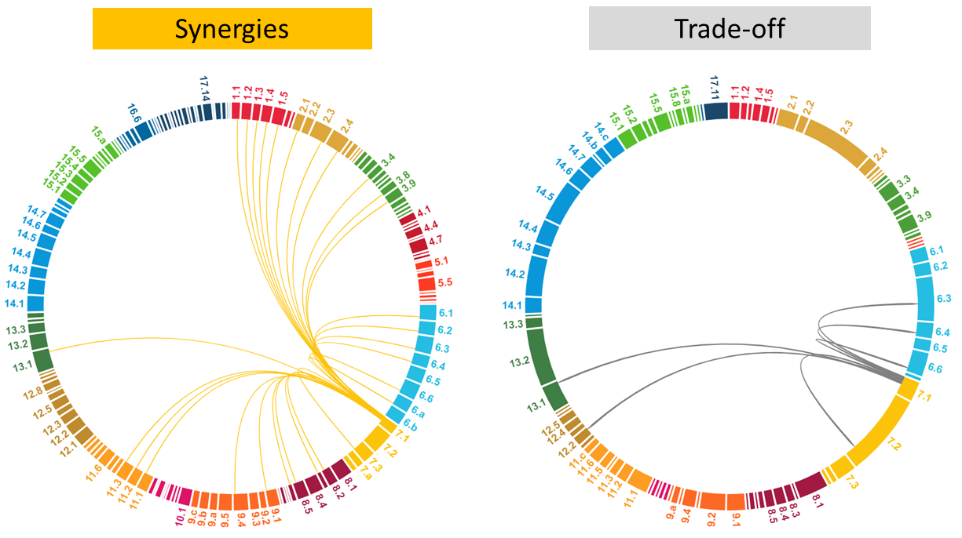

*Figure 1. Circular Sankey Chart representing synergies and trade-offs between SDG 7.1 and other SDGs, based on the JRC SDG Interlinkages Tool developed by the European Commission*

Despite significant progress in electricity access globally, challenges persist. The COVID-19 and complexities in reaching remote areas slowed progress, leaving 733 million without electricity and 2.8 billion people relying on polluting fuels for cooking in 2020. The majority of these populations live in sub-Saharan Africa, Asia, especially in Least Developed Countries (LDCs) and rural areas. Economic strains due to the pandemic hindered access for up to 90 million. If trends continue, an estimated 670 million will lack electricity by 2030, with one-fourth of the world's population still lacking clean cooking. Addressing this gap requires a major push to assist those living in the least developed areas and in fragile and conflict-affected countries. The goal of ensuring universal access to affordable, reliable, and modern energy services, such as electricity and clean cooking mechanisms, is framed within SDG 7.1. Its interconnectedness with various goals (Figure 1) offers synergies to address multiple global challenges, amplifying opportunities for education, health, food security and economic development. However, this goal necessitates balancing energy sufficiency and affordability, ensuring effective battery management, while guaranteeing inclusiveness and gender-responsiveness. The subsequent sections provide a concise explanation of these synergies and trade-offs, supported by relevant case studies.

#### Maximizing Synergies in Sustainable Energy Access

**Enlightening Education**: Well-lit, heated, and cooled schools and households create comfortable and effective learning spaces for children and adults (SDG 4). Illumination extends education opportunities into evening classes, catering to diverse schedules. Modern information and communication technologies (SDG 9), powered through electricity access, significantly enhance learning experiences and foster digital literacy. Access to affordable, reliable, and modern energy in schools significantly improves education quality and accessibility. Furthermore, access to the Internet supports digital connectivity of rural schools, which during COVID-19 has been key for educational resilience (ICSU, 2017). Access to quality education results in enhanced educational attainment and high completion rates, providing lifelong benefits to children.

**Enhancing Health Services and Water Access through Electricity**: Access to reliable electricity is fundamental for health services (SDG 3), safe childbirth, vaccinations, diagnostics, and emergency response (WHO, 2023). Nearly 1 billion people in low- and lower-middle-income countries lack reliable electricity in healthcare facilities (WHO, 2023). Electricity enables rural populations to store and refrigerate medicines and vaccines, ensuring community health. It powers vital medical devices, lighting and communications. Electricity is also key for improving household health conditions, through clean indoor environments, cooking facilities, and thermal comfort (heating and cooling). Energy also contributes to expanding water and sanitation services (SDG 6), particularly in water-stressed regions. Decentralized solar PV water pumps can replace more expensive diesel pumps and mini-grids can power filtration technologies, such as reverse osmosis systems, to produce clean drinking water (IEA, 2023), powering a shift toward unconventional water supply options (e.g. desalination). In schools, energy can power refrigeration and access to water and sanitation, essential for children’s health and safe nutrition. For instance, Solar PV systems and solar pumps installed by UNICEF (**Box 1**) have been used successfully in educational facilities to provide better access to safe water and hygienic sanitation.

**Box 1:** In 2019, The UNICEF’s Solar-powered water systems program installed more than 1,200 solar-powered water systems in over 40 countries across six regions, providing water to the most vulnerable children and their families in remote areas. The initiative deployed renewable energy access solutions prioritizing public service facilities such as health facilities, schools, and community centers. In Nigeria, 371 systems helped provide water and power to 52 schools and 85 health-care facilities, and large-scale solar-powered systems were implemented in Afghanistan, Somalia, South Sudan and Yemen in emergency contexts.

**Leveraging Electricity for Food Security and Productive Development**: Providing affordable, reliable, and modern energy services to the world's poor aligns with poverty eradication and reducing inequalities (SDG 1 and 10). In rural areas, where many lack energy access, empowering impoverished farmers with energy facilitates groundwater pumping, mechanization of farming, and maintenance of temperature-controlled supply chains. This enhances food crop yields, diversifies regional diets, and contributes to income generation (SDG2 and SDG 8). The World Bank projects that by 2030, two-thirds of the world’s extreme poor will live in fragile, conflict and violence settings. As a result, achieving SDG 2 (Zero Hunger) and SDG 10 (Reduce Inequalities) demands innovative solutions. The adoption of solar-powered irrigation systems in Yemen is an example of an innovative and conflict-resilient practice that has safeguarded food production capacities (**Box 2**).

**Box 2:** Between 2018 and 2022, the Yemen Emergency Electricity Access Project (YEEAP) spearheaded the expansion of electricity access in rural and peri-urban areas through solar solutions. This World Bank-funded initiative, executed by the United Nations Office for Project Services (UNOPS) alongside local entities, empowered six microfinance institutions to introduce financing products for small-scale energy systems. Over 3.2 million people, notably 51% female, accessed critical services like water, education, and healthcare, including support for COVID-19, through solar-powered facilities.

**Energizing Gender Equality:** Household air pollution causes around [13 deaths per minute](https://healthyclimateletter.net/" \t "_blank), mostly affecting women and girls who shoulder household responsibilities and face exposure to polluting lighting and cooking methods (SDG 3 and 5) (ICSU, 2017). Women and girls, spending up to 18 hours weekly on wood gathering and household cooking. (UNDP, 2022). Therefore, access to clean energy directly aids in reducing women's time poverty, for instance thanks to equipment such as fridges and washing machines, allowing better educational attendance.

Furthermore, access to energy is a key enabler for broadening opportunities for women. Studies indicate a 9 to 23% increase in women's employment post-electrification (UN, 2022). Public outdoor lighting increases security for women and girls, allowing more autonomy after dark and reducing exposure to gender-based violence.

Information technologies and the Internet reduce the digital divide and foster digital inclusion for women and girls (WEF, 2023) (ITU, 2020). Empowered women are more likely to drive local initiatives benefiting from cleaner cooking and lighting, which directly impacts their lives.

UNDP’s integrated projects in India and Nepal have shown promising results toward energy access, women’s equality and productive opportunities development (**Box 3**). UN Women's efforts in Ethiopia, included interest-free loans and entrepreneurship training benefiting over 19,500 women, enabling them to invest in an energy-saving cooking stove cooperative (**Box 4**).

**Box 3:** UNDP's energy access projects have significantly bolstered livelihoods, particularly for women, increasing income potential by up to 2.5 times. In India's Jharkhand State, solar stations facilitated by the UNDP have empowered women-run micro-enterprises, enabling them to produce essential hygiene products while earning an income. Similarly, in Nepal's Solta Bazaar, a solar minigrid supported a health lab and an IT training center, providing crucial services and education, sparing women long journeys for medical care.

**Box 4:** The UN Women-Joint Programme, initiated in Ethiopia in 2011, unites six UN agencies to bolster gender equality and women's empowerment. With a focus on all 11 regions, it aligns with Ethiopia's development frameworks, aiming to enhance women's income, education, and rights while promoting leadership. Supported by Sweden and Norway, the program includes interest-free loans and business skill development, creating a revolving fund for women's empowerment. Notably, the initiative has enabled women, to invest in an energy-saving cooking stove cooperative, fostering economic empowerment within their village and beyond.

#### Overcoming Energy Access Trade-offs

**Balancing Affordability and Sufficiency**: Energy sufficiency and affordability pose challenges in transitioning to clean energy technologies, potentially leading to a return to polluting energy sources. Off-grid solutions, with low capacities, might fail to meet surging demand, necessitating a reliance on polluting fuels. The lack of reliable energy availability can breed dissatisfaction among users, eroding confidence in clean energy sources. A similar dilemma arises in clean cooking: high upfront costs and unreliable LPG supply hinder rural communities from abandoning biomass (UCL, 2021). The United Nations Joint Programme for Sustainable Charcoal Reduction and Alternative Livelihoods (PROSCAL), implemented an integrated approach for the reduction of charcoal consumption in Somalia (**Box 5**).

On the contrary, increased access to affordable, reliable energy can inadvertently foster wasteful water consumption and overexploitation of resources, known as the "rebound effect". For instance, unconventional water supply options such as desalination are highly energy-intensive (ICSU, 2017). This phenomenon extends to agricultural practices. Strategies focused on energy sufficiency measures, affordability mechanism, and capacity building have shown promise in mitigating these rebound effects (WBG, 2017) (WLPGA, 2018).

Case Study 1: RBA: United Nations Joint Program for Sustainable Charcoal Reduction and Alternative Livelihoods (PROSCAL)

|  |
| --- |
| **Case Study: RBA: United Nations Joint Program for Sustainable Charcoal Reduction and Alternative Livelihoods (PROSCAL)** Location: Somalia  <https://info.undp.org/docs/pdc/Documents/SOM/PROSCAL-%20PIP%20-%202016.pdf>  <https://open.undp.org/projects/00085377>  The United Nations Joint Program for Sustainable Charcoal Reduction and Alternative Livelihoods (PROSCAL) ran from 2016 to 2022 with the objective of reducing unsustainable charcoal production, trade, and usage in Somalia. It sought to bolster energy security and livelihoods by engaging stakeholders, enforcing trade bans, developing alternative energy, transitioning charcoal practices, and promoting reforestation. PROSCAL's interventions aimed to create local economic opportunities, diminish poverty, halt environmental degradation, improve energy security, foster resilience among vulnerable groups, diversify energy sources, mitigate conflict, and promote peace and development. |

**Ensuring Sustainable Batteries Management:** Renewable-based energy access solutions, such as solar or wind, heavily rely on batteries to overcome natural resources’ intermittence. However, improper maintenance and disposal of batteries can lead to severe pollution, impacting human health (SDG 3) and ecosystems (SDG 14-15). With millions of these products sold in recent years, effective waste management will become increasingly important (Lighting Global, 2022). Stakeholders and companies must prioritize robust commitment to proper battery management, covering maintenance, security standards, and disposal. E-waste regulation planning is becoming integral to operational plans, fostering innovation and strategic partnerships, especially in regions lacking e-waste infrastructure. For example, only a few countries in sub-Saharan Africa (including Rwanda, Nigeria, Kenya and South Africa), have e-waste management facilities, equipped for off-grid solar value-chain recycling, and cross-boundary movement is expensive and complex. The scarcity of e-waste management facilities capable of handling end-of-life products from off-grid solar necessitates immediate attention and action (Lighting Global, 2022) (other sources). The Global Battery Alliance (**Box 6**) has emerged to tackle these challenges. In their recent report, the Alliance highlights the need for pilot projects aimed at launching and scaling effective corporate reverse logistics programs. Additionally, they advocate for establishing traceability and disclosure systems to address these critical issues (GBA, 2021).

**Box 6:** The Global Battery Alliance (GBA), initiated at the World Economic Forum in 2017, aims to ensure a sustainable battery value chain by 2030 through a collective effort involving international organizations, NGOs, industry, academia, and governments. This alliance focuses on Action Partnerships, tackling critical areas like establishing global criteria for sustainable batteries, ensuring responsible sourcing of materials, and promoting energy access in emerging economies while emphasizing circular practices to reduce lead poisoning and environmental impacts.

**The Moment of Leaving No One Behind**: Remote communities lacking grid access, marked by low population density, incomes, challenging terrains, and poor infrastructure, confront significant hurdles in accessing electricity. These communities can be grouped into three categories: geographically remote regions like rural settings, mountainous areas, small islands, and deep forests; communities with a remote chance of gaining grid access, including displaced refugees due to conflict or natural disasters; and those fully dependent on off-grid energy with minimal demand profiles, such as Indigenous communities. Despite varying characteristics, these settlements share commonalities in low electricity needs, economic and energy poverty, and a remote likelihood of obtaining grid-based electricity supply (IRENA, 2023). The diverse profile of last-mile communities necessitates community-centric models to ensure tailored solutions that fit their unique characteristics and needs. Successful and inclusive projects in the Hindu Kush Himalaya region (**Box 7**) showcase effective approaches addressing the challenges of last-mile regions (HIMAP, 2019) (ADB, 2023).

**Box 7:** Through an intervention called “Creating Self Sustainable, Smart and Low Carbon Villages”, the Global Himalayan Expedition (GHE) is helping remote Himalayan communities lacking electricity access to transform through locally designed, locally implemented and locally maintained solutions. Their aim is to bring about holistic change by merging the elements of sustainability, clean cooking, digital education, homestay tourism and solar-based electrification. Being connected with a solar grid gives villages a future and protects their cultural heritage.

**Avoiding Gender Blindness in Energy Access:** Social norms and gender roles can hinder women from benefiting equally from energy access initiatives, discourage them from participating in the sector’s labor force, and impacting their inclusion in decision-making processes. Gender-blind initiatives counteract women's equality, worsening gender gaps in energy poverty (SDG Action, 2023). Affordability mechanisms that neglect women deepen dependency, as they often receive lower salaries and depend on men's income. Low-capacity electricity systems, like small-capacity SHS, can perpetuate women's reliance on polluting mechanisms. While clean light intends to enhance work hours, it may burden women with longer schedules, reducing rest time.

Women are particularly vulnerable in conflict, disaster, and emergency settings, with millions forcibly displaced, lacking access to modern lighting and facing risks like violence and fuel-related challenges.

The lack of gender-responsive training for off-grid systems can exclude women, hindering initiatives and reinforcing gender inequality. The enabling environment for women's participation in the energy sector requires gender-responsive planning, policymaking, regulation, and progress tracking through gender-disaggregated data collection and analysis (SDGs UN, 2021). Making women being agents of change improve energy access initiatives development

### SDG 7.2 Renewable energy

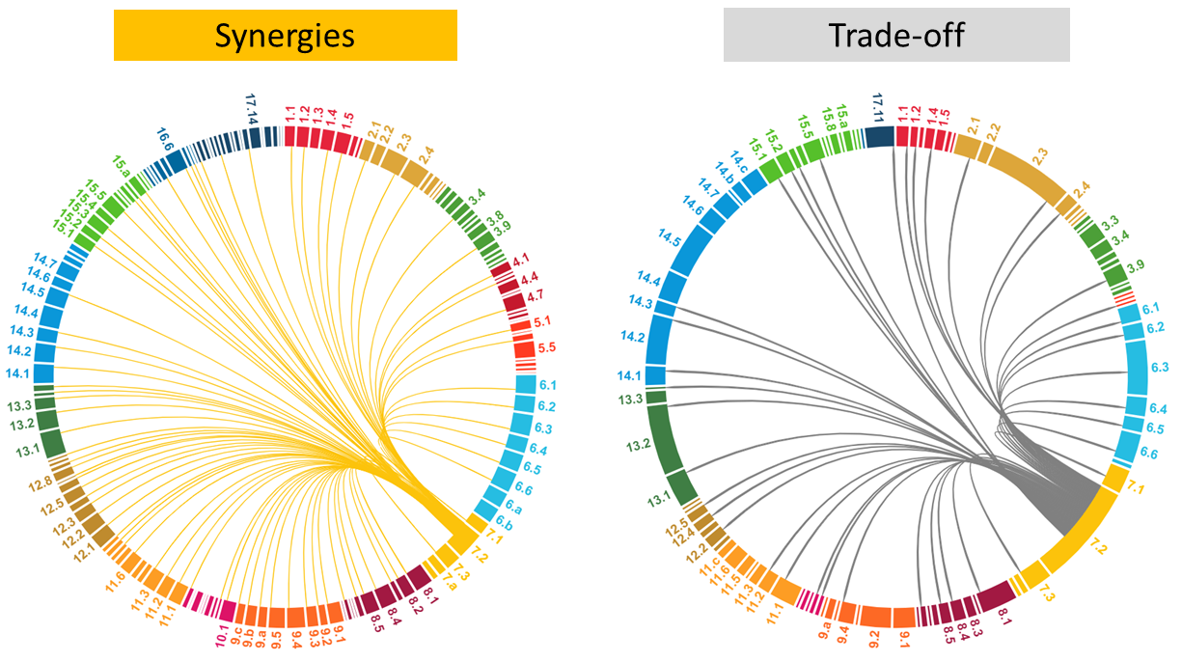

*Figure 2. Circular Sankey Chart representing synergies and trade-offs between SDG 7.2 and others SDGs, based on the JRC SDG Interlinkages Tool developed by the European Commission*

Energy is one of the main contributors to climate change, accounting for 73% of human-caused greenhouse gases. The developing world, particularly Africa with its carbon emissions accounting for less than [three percent](https://www.iea.org/reports/africa-energy-outlook-2022" \t "_blank) of global energy-related emissions, will bear the brunt of climate change impacts. Renewable energy use rose to 17.7 % in 2019, notably in electricity generation, hitting 26.2 %. Investment costs for small-scale renewable energy technologies (e.g., Solar Home Systems) dropped considerably in recent years, making these solutions competitive and signaling wider profitability ahead (ICSU, 2017). Some of the poorer regions of the world possess high-quality renewable resources (e.g. biomass and solar power in Africa), offering potential for poverty alleviation if leveraged effectively (ICSU, 2017). However, progress needs acceleration, especially in heating and transport sectors. Effective climate action demands bolstering policy support across all sectors and enhancing tools to mobilize private capital (UN-Habitat, 2022). Increasing renewable energy adoption aligns with SDG 7.2 and interconnects with multiple goals, offering solutions to various global challenges while providing opportunities for health, jobs, and gender equality. They also mitigate climate change impact and improve cities and communities’ resilience. However, renewable energy initiatives should place particular attention to trade-offs such as water stress, land use conflicts, life cycle environmental impacts and governance issues, emphasizing community rights and sustainability. This section highlights complexities in renewable energy's impacts and initiatives aiding comprehensive understanding of its effects. This section explores renewable energy's complexities and includes case studies for a comprehensive understanding of its impacts.

#### Advancing Sustainable Prosperity with Renewable Energy

**Clean Energy for Climate Action**: Accelerating the penetration of renewable energy aligns with the Paris Agreement's goal of limiting global warming to below 2°C (SDG 13) (ICSU, 2017). Renewable energy sources are less water-intensive than conventional sources, which is highly relevant amid water scarcity and erratic flows caused by climate change. The global energy system used 10% of total global freshwater withdrawals in 2021, due to the essential role of water in the energy supply chain, from electricity generation to fossil fuel production (IEA, 2023). The IEA’s [Net Zero Emissions by 2050 Scenario](https://www.iea.org/reports/global-energy-and-climate-model/net-zero-emissions-by-2050-scenario-nze) predicts a nearly 15% decline in water use within the power sector due to transitioning from coal to solar PV and wind energy.

Replacing off-shore petroleum extraction by renewable energy generated from offshore wind, wave and tidal power farms can contribute to conserving and sustainably using marine resources (SDG 14). Upscaling of renewables will help decrease ocean acidification (via lower carbon emissions), accidental impacts from energy-production and transport activities on aquatic habitats, and marine thermal pollution from cooling at coastal power plants (ICSU, 2017).

**Healthier Cities and Resilient Societies:** The use of renewable energy resources directly reduces air pollution. Improving air quality, and by extension human health, is especially important for those living in the dense urban centers of rapidly developing countries (SDG 3) (ICSU, 2017). Resilient infrastructure, inclusive industrialization, and innovation (SDG 9) are prerequisites for achieving the SDG 7.2 target (ICSU, 2017). Clean energy systems, in particular, create the conditions for cities and human settlements to be inclusive, safe, resilient, less-polluting, and more sustainable (SDG 11). An up-scaling of renewable energy can have a large impact on the sustainability of cities and communities. Similarly, sustainable urban planning, transport, and housing are key for achieving SDG 7.2, since renewable solutions are fundamental pillars of the solutions portfolio. Smart grids and energy communities facilitate the development of renewable energy at the domestic or neighborhood scale (ICSU, 2017). Furthermore, decentralized renewable energy sources enhance resilience. This is exemplified by the City Energy Resilience Framework, developed by the Resilient Cities Network (R-Cities) and Urban Power (**Box 8**).

**Box 8:** The City Energy Resilience Framework (CERF) serves as a comprehensive guide for cities to bolster their energy transition and urban resilience. It encompasses aspects of electricity infrastructure, clean energy, equitable service access, emergency management, and recovery strategies. As an engagement tool, CERF unites stakeholders to evaluate challenges and opportunities for resilient energy systems based on local policies and initiatives. By highlighting global examples, CERF encourages dialogue on adopting multi-benefit energy solutions that empower urban communities to adapt and thrive amidst adversities.

**Inclusive Working Opportunities**: Renewable energy deployment bolsters innovation and reinforces local, regional, and national employment objectives (SDG 8). The global renewable energy sector employs 12.7 million people, with significant growth in solar PV, primarily in Asia accounting for 79% of the global total. Wind and hydropower, as well as liquid biofuels make up most of the rest of the growth in renewable energy jobs. China dominates employment in most renewable energy sectors, however Brazil has the most biofuel jobs (WEF, 2023). While gender parity remains low in the renewable energy sector and technical positions, companies with at least 30% female leadership yield higher profit margins and are more inclined to invest in sustainability and environmental initiatives (SDGs, 2022). Renewable energy’s value chain presents new opportunities, particularly for women (SDG 5), as greater gender diversity has shown to enhance both effectiveness and financial performance. A fair energy transition is essential for equalizing opportunities in employment and leadership roles, emphasizing the importance of access to quality jobs and finance in empowering women and their families (UN Women). UNDP-supported initiatives in [Peru](https://undp-climate.exposure.co/empowered-women) (**Box 9**) and [Yemen](https://www.undp.org/yemen/stories/yemeni-rural-women-launch-country%E2%80%99s-first-private-solar-energy-grid) (**Box 10**) showcase women's impact as clean energy promotors.

Case Study 2: RBLAC: e-Mujer, the Energy School for Women.

|  |
| --- |
| **Case Study: *RBLAC:* e-Mujer, the Energy School for Women** Location: Perú  <https://undp-climate.exposure.co/empowered-women>  In Peru, e-Mujer, the Energy School for Women. This pilot project, funded by the Global Environment Facility and implemented by the Peruvian Ministry of Energy and Mines and the United Nations Development Programme, trains rural women to use, install, maintain, and commercialize clean energy systems such as solar panels and improved cookstoves. |

**Box 10:** In Yemen, rural women led the establishment of the nation's first private solar energy grid under the Enhanced Rural Resilience in Yemen (ERRY) Joint Programme. Supported by the European Union (EU) and implemented by FAO, ILO, UNDP, and WFP across four Yemeni governorates, this initiative empowered ten female entrepreneurs through UNDP's 3x6 Approach. Over three years, the project aims to strengthen crisis-affected rural communities, focusing on sustainable livelihoods, food security, governance, social cohesion, and access to sustainable energy. UNDP collaborates with the Sustainable Development Foundation (SDF) in this endeavor.

#### Managing Trade-offs in Renewable Energy for Sustainable Development

**Water Security Challenges of the Clean Energy Transition:** Transitioning from fossil energy to renewables generally reduces water consumption and limits thermal and chemical pollution into aquatic ecosystems. Yet, mismanaged renewable sources like bioenergy and hydropower could exacerbate existing water-related issues (ICSU, 2017) (SDG 6). Furthermore, growing water stress in dry regions poses a threat to the power sector regarding energy security, potentially reducing hydropower generation in regions with declining water flows such as southern Europe, North Africa and the Middle East. Variability in hydropower production has worsened the global energy crisis. Reduced hydropower generation in Latin America during 2021 drove up the demand for liquefied natural gas, resulting in early pressure on natural gas prices. Similarly, the significant drop in hydropower output in southern Europe in 2022 compounded the strain on gas and electricity markets due to Russia's invasion of Ukraine, leading to cuts in pipeline gas deliveries (IEA, 2023).

**Balancing Land use for Renewable Energy and Food Security:** Compared to conventional sources, renewables often demand more land, potentially conflicting with ecosystem protection (SDG 15) and food security (SDG 2). Scaling up bioenergy might clash with efforts to sustainably manage forests, halt deforestation, and protect biodiversity through practices like monocropping for energy crops and large-scale solar installations. Developing agrofuels could elevate global food prices and compete for agricultural resources, impacting affordability and access to food for the vulnerable (ICSU, 2017). Large-scale renewable projects, especially hydroelectric dams, significantly affect land use, disrupting local economies such as agriculture and fishing and aggravating food security (SDGs, 2022). Local land-use changes can scale up impacts at global scale, requiring international coordination and systemic approaches (ICSU, 2017). Multiple land uses and integrated solutions can reduce adverse impacts of renewable energy. Bioenergy’s unique aspect lies in its potential as a land management co-product, supporting ecological services like soil restoration, wildfire prevention, and habitat preservation (SDGs, 2022). Adopting policies that prioritize bioenergy crop growth on degraded lands can mitigate global agricultural market impacts while enhancing soil health and biodiversity (ICSU, 2017). Notably, the “Solar Pyramid”, project in Curitiba, Brazil, utilized landfills for solar power plants, supported by C40’s network, a coalition of mayors fighting climate change (**Box 11**). Emerging technologies like agrivoltaics serve as innovative integrated land-use systems, enabling simultaneous production of food, electricity, and water, (FAO, 2021) (EU Science Hub, 2023), as exemplified by the Indian case study (**Box 12**)

**Box 11:** The Solar Pyramid launched in 2023 in Curitiba is the Latin America's first solar plant on a former landfill, backed by C40's CFF. This landmark project demonstrates how cities can achieve clean, affordable energy while decreasing reliance on fossil fuels in their urban grids. The city primarily relies on hydroelectric power but faces energy shortages during droughts, resorting to fossil gas and coal plants. The Solar Pyramid supplies 8MW of energy capacity across Curitiba, slashing CO2 emissions by 90,000 tonnes (2020-2050), akin to removing 20,000 cars yearly. Additionally, it generates US$500,000 annually by substituting grid electricity with solar production.

**Box 12:** Agrivoltaics is rapidly expanding globally, and India is initiating its adoption with over a dozen pilot projects nationwide. A research led by the International Institute for Sustainable Development (IISD), evaluates the current development status, outlining challenges and opportunities for Agrivoltaics commercialization in India. The work aims to expedite adoption by offering policy recommendations, proposing business models, and providing a financial and technical transitions mechanism for state agencies, developers, and stakeholders.

**Environmental Footprint of Green Energy Value Chain:** Renewable energies' impact on water resources (SDG 14) and (SDG 15) land footprints extend across their entire value chain. The extraction of minerals necessary for manufacturing renewable components like solar, wind, and batteries, coupled with challenges in end-of-life recycling, significantly influences their environmental implications. Subterranean footprints from drilling boreholes or fracking can affect water aquifers and geological formations. Evaluating their environmental footprint mandates a comprehensive assessment of land impacts, considering the entire life cycle, from fuel extraction to decommissioning. Notably, a single energy technology can vary significantly in its land footprint. For example, solar panels made from cadmium have a smaller land footprint compared to silicon panels (Our World in Data, 2022). These environmental impacts, including mining materials and energy consumption during refining processes, underscore the critical role of deployment choices and technological considerations.

**Governance and Community Rights in Renewable Energy:** The pursuit of critical energy transition materials drives attention toward sustainable socioeconomic growth. Renewable energy manufacturing Initiatives can bolster local manufacturing and create jobs, but can also contribute to environmental harm and exploitation of workers and communities (SDG 8). Efforts to secure these resources through export bans and industry nationalization align with national economic interests but require comprehensive approaches that uphold community rights, labor rights, and environmental sustainability (IRENA, 2023). Moreover, large-scale renewable energy projects, such as hydropower dams or bioenergy, can disrupt traditional land management, impact on community cohesion and violate legitimate land tenure rights (SDG 1). Documented human rights abuses, including threats, land grabs and harm to indigenous communities, highlight the need for establishing clear policies to protect human rights, involving stakeholders, and providing accessible redress mechanisms in renewable energy projects (OHCHR, 2016) (CCSI, 2023). For instance, the UN Guiding Principles on Business and Human Rights outline steps companies must take to respect human rights and provide remedies for harms their operations cause or contribute to (Amnesty, 2023). A socio-economic footprint analysis of the energy transition performed by IRENA in South Africa and Egypt, enhance the comprehensive assessment of renewable energy potential impacts on environment, people and livelihoods protection and jobs creation (**Box 13**).

**Box 13:** IRENA's assessment of the energy transition's socio-economic impact in South Africa and Egypt builds on its World Energy Transitions Outlook. This effort aims to support transition planning and informed policymaking. The South African report showcases a wind project and the establishment of a Small-Medium Enterprise focused on bird monitoring. This project enhanced positive socio-economic impacts on local communities by creating new professional opportunities for disadvantaged community members and fostering bird protection mechanisms.

### SDG 7.3 Energy efficiency

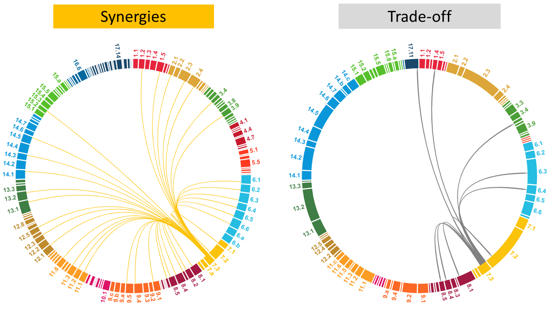

*Figure 3. Circular Sankey Chart representing synergies and trade-offs between SDG 7.3 and other SDGs, based on the JRC SDG Interlinkages Tool developed by the European Commission*

Energy efficiency is key for achieving a balanced human development while reducing the impacts on the planet. The right efficiency policies could enable the world to achieve more than 40% of the emissions cuts needed to reach climate goals without new technologies. To meet the Goal 7 and compensate for lost time, necessitates a yearly average improvement in energy intensity of 3.2 % until 2030. Framed within SDG 7.3, this global energy efficiency target requires significant reductions in energy consumption, presenting both synergies and trade-offs on global and local scales (Figure 3). Energy efficiency presents synergistic opportunities of reducing planetary impacts and promoting sustainable societies, managing the water-food-energy nexus, improving waste-to-energy strategies and leveraging digitalization. Yet, adopting these measures faces challenges: managing industrial degrowth complexities, scaling nature-based solutions for inequality and land challenges, and closing the triple digital divide in smart agriculture. Achieving energy efficiency requires a shift in behavioral paradigms, reliant on sustainability education and enhanced cooperation. The subsequent sections offer concise insights into these synergies and trade-offs, complemented by relevant case studies for illustration.

#### Catalyzing Sustainability through Energy Efficiency

**Building Sustainable Societies through Energy Efficiency:** Energy efficiency is key to reducing several adverse effects of the two previous SDG 7.1 and SDG 7.2. On the one hand, energy efficiency measures can avoid the rebound effect of energy access. For instance, an integrated solution developed by the ICLEI organization enhanced to improve water and energy efficiency of health centers and maternity centers, addressing together several SDG such as 3, 5, 6 and 7 (**Box 14**), enhancing a more positive impact of energy access interventions. On the other side, since energy efficiency reduces the amount of energy consumption, it has direct impacts on reducing energy-related environmental effects on climate (SDG 13). The Green Economic Development Project developed by the UNDP in Bosnia Herzegovina enhanced saving 700,000 USD annually, reducing emissions of 2.200 tons of CO2 annually and creating jobs for 664 persons / month (SDG 8) (**Box 15**), contributing to sustainable cities, climate, education and energy goals. Nature-based solutions are gaining traction, counteracting heat waves and high temperatures in urban settings. By incorporating elements like blue infrastructure and green roofs, these approaches reduce energy consumption and enhance urban microclimates (SDG 11) (WB, 2023)

**Box 14:** In Rwanda, the Urban-LEDS II pilot projects in Muhanga District and Kigali are transforming healthcare by upgrading the Gitarama and Gahanga Health Centers. These initiatives introduce cost-effective and sustainable systems, including rainwater harvesting tanks and energy-efficient lighting solutions such as solar-powered streetlights and high-pressure solar water heaters. These upgrades aim to reduce operational costs, enhance climate resilience post-COVID-19, and are backed by partnerships with ICLEI, a global network for sustainable urban development. This pilot project is strengthening Rwanda's innovative, eco-friendly healthcare solutions for a greener future.

**Box 15:** The Green Economic Development Project developed by the UNDP from 2012 to 2022 has improved the energy efficiency of public buildings in Bosnia and Herzegovina for climate comfort. It has promoted fuel switch projects, automated energy consumption regulation and management of public-sector buildings, and implemented efficient public lighting. Education and capacity-building on energy management of public-sector buildings for end-users have also been provided.

**Optimizing the Water-Food-Energy Nexus for Sustainability:** The growing demand for water (SDG 6), food (SDG 2), and energy (SDG 7) exerts immense pressure on this interconnected nexus. For instance, shifting dietary patterns towards water-intensive foods, coupled with an anticipated population surge to over 9 billion by 2050, necessitates a staggering 50% increase in global food production. Agriculture, a major consumer of freshwater resources, accounts for nearly 30% of global energy consumption. Integrated and efficient management of water, food, and energy presents synergistic opportunities to address these multiple challenges. Optimizing power plant operations, deploying advanced cooling systems, and embracing energy-efficient irrigation present viable solutions. Water services, acting as a cornerstone for demand-side energy management, offer opportunities for power generation and storage, with irrigation adjustments during low electricity demand periods and reduced pumping during peaks (IEA, 2023). The intertwined nature of land, soil, and water systems calls for comprehensive efficiency measures across the agri-food chain. Precision irrigation guided by water providers' data and the safeguarding of ecosystems alongside agricultural and energy production are novel solutions to ensure environmental sustainability (UN Water, 2023). Efficient cold chain solutions are also key for supporting food security while reducing food waste (FAO, 2021).

**Waste-to-Energy Solutions:** Waste-based energy generation not only serves as an energy-efficient solution but also aligns with multiple Sustainable Development Goals (SDGs). Connecting SDG 7.2 and 7.3, it contributes to low-impact energy generation while addressing waste reduction, resource efficiency, fostering innovation, and building resilient infrastructure (SDG 9, 11 and 12). Certain bioenergy forms, derived from domestic waste, avert competition with food production (ICSU, 2017). Technological advancements, particularly in wastewater management, offer synergistic opportunities. The energy latent in wastewater alone can satisfy over half of a treatment plant's electricity needs (IEA, 2023). Implementing energy-efficient technologies reshapes consumption patterns, fostering responsible consumption and production while minimizing waste-associated energy consumption (ICSU, 2017). The IRENA report underscores the potential of agricultural residue-based bioenergy in Southeast Asia, Sub-Saharan African and South America (IRENA, 2023). UNDP’s project in Sri Lanka promoted the use of bioenergy as a waste management strategy within the agro-industry (**Box 16**).

**Box 16:** The UNDP's project in Sri Lanka, spanning 2019 to 2023, targets sustainable energy use in the Agro-Industry to cut emissions and boost savings. Focused on solar energy and biogas, the project exemplifies a South-South cooperation led by China. It aims to build capacity, transfer technology, and apply innovative waste-to-energy solutions, including converting slurry into organic fertilizer. By showcasing energy-efficient applications, waste management, and productivity gains, the project benefits from China's expertise, fostering capacity development in partner countries.

**Digitalization for Efficiency:** Integrating digital solutions with energy infrastructure creates synergies, enabling increased efficiency and productivity (SDG 9, 11, 12). Fourth Industrial Revolution technologies, like real-time analytics, significantly enhance energy efficiency and reduce waste across various channels (UNDP, 2018). Developing nations have immense potential to adopt Industry 4.0 in manufacturing, employing smart production tools like sensors and Artificial Intelligences (AI) to enhance productivity and minimize environmental impact (UN, 2022). Agriculture 4.0 is also emerging for enhanced farming practices. Agricultural automation trends include creating specialized equipment for farming tasks and converting standard machinery into autonomous systems (FAO, 2020). Smart cities and grids, driven by digital tech, optimize urban infrastructure and energy networks. UNDP-supported projects in places like Mauritius introduce smart grid solutions that automate responses to outages and improve reliability and power quality. In Bosnia and Herzegovina, digital tech monitors and reduces building power consumption, critical for emissions reduction. Tracking energy use and emissions in 75% of buildings aids in efficient planning and disaster mitigation (**Box 15**) (UNDP, 2023).

#### Developing Informed Strategies for Energy Efficiency Trade-offs

**Mitigating Development Degrowth:** Mitigating industrial degrowth in developing nations while pursuing SDG 7.3 involves a delicate balance. Prioritizing energy efficiency must not impede industrial progress but rather encourage sustainable development and industrialization. Concerns arise around the early retirement of fossil energy infrastructure, where policies like carbon pricing can aid innovation and compliance in the industrial sector (SDG 9) (ICSU, 2017). Implementing energy-from-waste strategies, such as fuels produced from domestic waste, requires energy-intensive transportation of waste residues and operation of agrofuel processing plants (ICSU, 2017). To avoid trade-offs, an integrated approach across the entire value chain is required. Moreover, defining energy efficiency strategies poses challenges due to varied definitions and their multifaceted impacts UNESCWA, 2016). While focusing on resource losses, efficiency measures need a more comprehensive view, integrating social, environmental, and sustainability factors. The nexus approach allows examining productivity in sectors such energy and water production, emphasizing decentralized generation and optimizing the entire supply chain, ensuring resource value is maximized.

**Scaling Nature-Based Solutions for Addressing Inequality and Land Challenges:** Nature-based solutions stand as a promising avenue for scaling up energy efficiency. However, the substantial land requirements of large-scale nature-based solutions, especially for climate change mitigation (i.e. carbon capture solutions), necessitate concurrent measures to alleviate land pressure, such as shifts in food systems and agriculture, to prevent potential conflicts. Inclusive design becomes critical considering the historical impact on marginalized communities amid land and climate changes. Challenges to wider adoption include limitations in ecosystem services, monitoring difficulties, and varying societal perceptions of climate risks (WWF, 2020). Mitigating potential trade-offs and avoiding exacerbating climate issues and social injustices require integrated, bottom-up approaches. UNDP's initiatives, particularly in tackling deforestation through nature-based solutions, exemplify this comprehensive strategy (**Box 17**).

**Box 17**: In Angola, where 88% of the multidimensionally poor reside in rural areas facing threats from deforestation and traditional energy usage, the UNDP collaborates with the government to address this critical issue. Angola's 2020-2022 development priority emphasizes natural resource management for conservation and economic growth. UNDP's approach involves integrated, nature-based solutions targeting deforestation and forest degradation. Efforts concentrate on sustainable forest management, notably community-based forestry, and enhancing the sustainability of the charcoal value chain. This includes promoting sustainable charcoal consumption practices in cities and integrating sustainability criteria into government policies, fostering long-term environmental preservation and benefiting rural communities.

**Closing the Triple Digital Divide in Agriculture 4.0:** Despite the promises of increased efficiency through digitalization and smart-agriculture innovations (SDG 2 and 9), challenges persist. Issues like data management, technology operation, and affordability hinder widespread adoption, particularly among small-scale farmers. Innovative approaches like service provision and cooperative ownership offer potential solutions to enhance accessibility. UNDP's Africa Minigrids Program utilizes digital innovation to scale solar minigrids, ensuring affordability through remote monitoring and real-time consumption tracking (**Box 18**). Agriculture 4.0 heavily relies on Information and Communication Technologies (ICTs), yet access to robust IT infrastructure remains a challenge, especially in rural areas of developing nations (FAO, 2020). Engaging youth, and particularly women (SDG 5), in Agriculture 4.0 and green economy initiatives presents opportunities for innovation and entrepreneurship, but necessitate a gender-responsive approach to overcome gender gaps in technology access and resource dependency pose challenges (UN Women Africa, 2023). To address these disparities, UN Women's study aims to minimize the triple divide impacting women and prepare youth for inclusive, environmentally sensitive livelihoods through gender-responsive programs integrated into climate-smart agriculture solutions (**Box 19**).

**Box 18:** UNDP's Africa Minigrids Program operates in 21 sub-Saharan countries, utilizing digital innovation to scale solar minigrids and revolutionize energy markets. This program is specifically aimed at early-stage minigrid markets, aiming to create an environment conducive to substantial private investment. Its goal is to enhance access to clean energy by bolstering the financial viability and encouraging significant commercial investment in renewable energy minigrids across Africa. The program focuses on cost-reduction strategies and innovative business models to achieve these objectives.

**Box 19:** In exploring opportunities for youth in agriculture across Mozambique, Rwanda, and Uganda, UN Women East and Southern Africa Regional Office (ESARO) emphasizes addressing challenges hindering youth engagement, notably gender inequality, limited access to resources, and the digital divide. Their report highlights disparities in job access within the agriculture sector, proposing comprehensive recommendations. These suggestions span capacity development in digital and business skills, quality assurance, intellectual rights protection, soil health, renewable energy, and agroecological farming. The focus extends to narrowing the digital divide, promoting gender equality, inclusive business models, and investing in tailored technologies for sustainable agriculture. Ultimately, these efforts aim to bolster youth opportunities while ensuring gender-inclusive, energy-efficient, and sustainable growth in the agricultural landscape.

**Sustainability Education for Shaping a Greener Future:** Effective achievement of energy efficiency goals demands broad cooperation (SDG 17) and necessitates education on sustainability (SDG 12). Creating widespread awareness and understanding among governments, industries, and communities is paramount for success (WEF, 2023). While technology is essential, influencing consumer behavior significantly impacts energy savings. Successful energy efficiency initiatives require a mix of technology-driven solutions and a deep understanding of human behavior. This emphasizes tailored, cost-effective approaches, continual evaluation, and engagement with communication experts in crafting effective behavior change campaigns. Behavioral approaches can reshape energy efficiency programs, focusing on behavior change and gender equality. These programs need to consider local contexts and consumer data, possibly integrating them into broader interventions (ESMAP, 2020). Education on energy efficiency encourages the development of technologies that minimize energy wastage and promotes collaborative research into renewable and clean energy resources (UNESCO, 2023) Overcoming challenges involves inclusive capacity-building efforts across sectors, focusing on individuals regardless of age or gender, particularly targeting women and youth (SDG 5) (FAO, 2020).

**TAKE-HOME MESSAGES**

• Access to electricity and clean cooking acts as a catalyst for achieving multiple SDGs, facilitating educational opportunities, bridging the digital divide, transforming health services, addressing water stress, bolstering food security and productive development, and narrowing the gender gaps. Special attention must be given to balancing energy affordability and sufficiency, ensuring sustainable battery management, and applying an inclusive, gender-responsive lens to leave no one behind.

• Renewable energies pave the way for sustainable prosperity, contributing to the synergistic fight against climate change, creating healthier cities, and fostering resilient societies. These technological solutions require a holistic approach to manage potential trade-offs, such as water security challenges, balancing land use and food security, considering the entire environmental footprint of the green energy value chain, and ensuring governance and community rights.

• Energy efficiency represents a highly advantageous strategy capable of catalyzing sustainability by building sustainable societies, optimizing the water-food-energy nexus, transforming the energy sector and industry through waste-to-energy solutions and digitalization. However, attention is needed to avoid development degrowth, to mitigate scaled impacts of large-scale initiatives such as nature-based solutions, to engage society through capacity-building and reduce inequalities through digitalization.

## Approaches, Methods and Tools for Strategic Innovation

This chapter explores ways to uncover system interconnections and foster integration across the SDGs. It aims at equipping participants with an understanding of why a focus on system interconnections is key for achieving sustainable development, what coherent policymaking entails, and what are some specific approaches, methods and tools that can be employed to foster SDGs interlinkages. Approaches are intended to guide the overarching strategy, methods define the step-by-step procedures, and tools provide the means to execute those procedures effectively within the chosen approach and method. For instance, the UNDP’s Knowledge Bank offers a one-stop-shop resource platform, including the SDG Integration tools and the SDG Acceleration Toolkit by the UNSDG, serving as a comprehensive support hub for achieving the Global Goals (SDG Acceleration Toolkit)

**SDG Acceleration Toolkit**:

The SDG Acceleration Toolkit is a compendium of tools for analysing system interconnections, enhancing policy coherence, ensuring that no one is left behind, identifying risks and building resilience. Originally launched in 2017 by the United Nations Sustainable Development Group (UNSDG), this refreshed version of the Toolkit is designed to provide UN Country Teams, policy experts and Governments with access to existing tools for accelerating progress toward the 2030 Agenda. The tools can also support immediate socio-economic response to the COVID-19 pandemic, as well as effective recovery planning and implementation. The Toolkit is managed jointly by UNICEF and UNDP under the auspices of the UNSDG Task Team on Integrated Policy Support.

### Approaches

This section introduces a range of approaches aimed at enhancing the comprehensive understanding of interconnected SDGs while operationalizing actions toward achieving multiple goals. These approaches serve as overarching strategies used to address complex problems, offering broad guidance on how to approach multifaceted issues. Specifically, it explores four complementary approaches within Sustainable Energy Initiatives. These include the System Thinking approach, aiding in understanding issues as interconnected systems; Gender Mainstreaming, which incorporates gender as an analytical variable, involving gender-responsive initiatives, policies, and actions; the Human Rights-Based Approach, emphasizing the fulfillment of human rights; and the Portfolio Approach, transitioning from isolated projects to an interconnected network through experiential learning.

#### System Thinking Approach

|  |  |  |
| --- | --- | --- |
| **What is it?**  An approach that views issues as interconnected systems rather than isolated parts. | **How does it work?**  It considers the relationships and feedback loops between various components within a system, examining how different parts interact and influence each other. | **Why apply it?**  It provides a holistic view of complex issues, identifies underlying causes, targets leverage points for effective interventions, and facilitates stakeholder identification and engagement. |

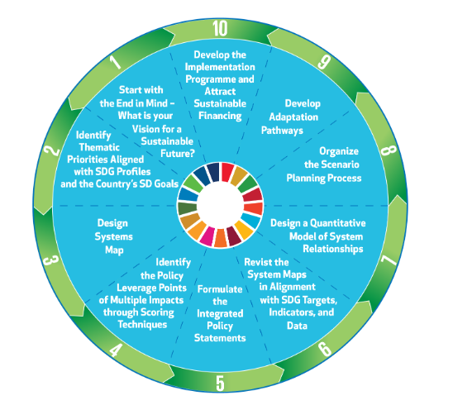

*Figure 4: 10-step participatory Systems Thinking Approach, tailored for UNESCAP sustainability outlook reports (UNESCAP, 2020)*

Systems thinking perceives issues as intricate systems rather than isolated elements, exploring interconnections and feedback loops among components. It aims to understand complex systems comprehensively, identifying stakeholders and their roles, uncovering root causes, pinpointing leverage points for impactful changes, and revealing interdependencies. It empowers policymakers to devise effective interventions by grasping driving forces within systems. Implementation involves recognizing boundaries, mapping interconnectedness, and using tools like system dynamics or causal loop diagrams. This approach requires a shift from viewing problems as isolated incidents to systemic constructs. Beneficial across the project cycle, especially in early stages for understanding complexity and during implementation for dynamic intervention adjustments, systems thinking offers a holistic view, addressing underlying causes and facilitating stakeholder engagement inclusively (UNSSC, 2020) (UNESCAP, 2015) (UNFCCC, 2015) (UNU-FLORES, 2015.

#### Gender Mainstreaming

|  |  |  |
| --- | --- | --- |
| **What is it?**  An approach that considers gender as an analytical variable, entailing a shift from gender-neutral to gender-responsive initiatives, policies, actions or processes. | **How does it work?**  Gender mainstreaming embodies the integration of a gender perspective across the entire spectrum of planning, implementation, monitoring, and evaluation within policies, programs, and actions spanning all sectors and levels | **Why apply it?**  It promotes gender equality by identifying and addressing disparities, ensuring equal benefits from policies and programs, and promoting inclusivity. |

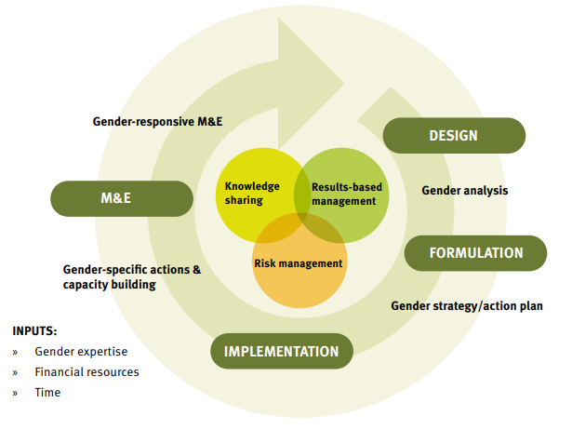

*Figure 5: UNIDO’s guide for Gender Mainstreaming at the different project cycle stages (UNIDO, 2021)*

Gender mainstreaming integrates a gender perspective into planning, implementation, monitoring, and evaluation across sectors and levels, ensuring women's and men's concerns become integral in initiatives to foster equality. Its core aim is to advance gender equality by identifying disparities and ensuring policies equally benefit both genders, eradicating discrimination. This methodical approach analyzes policies for gender implications, addresses gaps using data, implements gender-responsive actions, and monitors progress through sex-disaggregated and gender indicators, incorporating gender perspectives at every stage. Throughout the project cycle, from design to evaluation, gender mainstreaming ensures equitable program benefits, opposes discriminatory practices, amplifies initiative effectiveness through diverse perspectives, and aligns closely with the UN Charter's values of equality and inclusivity. (WEF, 2023) (UN, 2022) (UNIDO, 2021) (UNEP & EmPower, 2020) (UN Women & UNIDO, 2023).

**Data: The Gender Gap Report – World Economic Forum**

The Global Gender Gap Report, initiated by the World Economic Forum in 2006, benchmarks gender parity in economic opportunities, education, health, and political leadership across 146 countries. It measures parity scores between men and women, with a score of 1 indicating full parity. The report aids strategic planning and policy by identifying disparities and trends, offering a vital tool throughout the project cycle for achieving global gender equality.

**Indicators: Addressing Energy’s Interlinkages with other SDGs**

The SDG 7 Policy Briefs compilation, "Addressing Energy's Interlinkages to Other SDGs" developed by the SDG7 Technical Advisory Group (SDG7 TAG), delves into how energy access intertwines with SDG 5 (gender equality), identifying potential indicators and assessing data availability. This report porposes a set of indicators to measure the gender gap in term of: access to electricity and clean cooking, employment and leadership, energy entrepreneurship, and the regulatory environment.

#### Human Rights-Based Approach

|  |  |  |
| --- | --- | --- |
| **What is it?**  An approach emphasizing the fulfillment of human rights, shifting the focus from basic needs to rights. | **How does it work?**  It integrated human rights principles across all phases of development cooperation, aligns programming with international standards, and focuses on capacity building for both duty bearers and rights holders. | **Why apply it?**  It promotes equality, justice, and dignity for all, by addressing inequalities and discrimination at the root level. It empowers individuals and communities to claim their rights and enhances accountability and transparency in governance. |

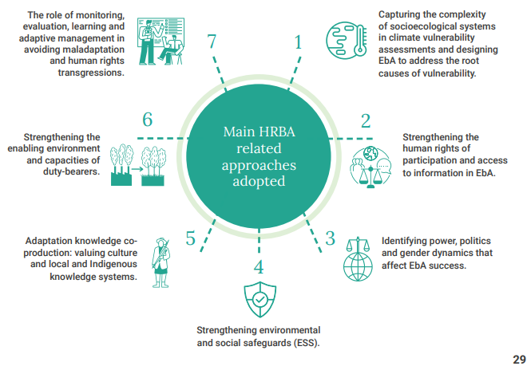

*Figure 6: Example of Human Rights-Based Approach applied in Ecosystem-based Adaptation (EbA) (UNEP, 2022)*

Human Rights-Based Approaches (HRBA) are deeply rooted in international human rights standards, aimed at safeguarding human rights within developmental landscapes. It emphasizes realizing human rights outlined in international agreements to rectify discriminatory practices and rebalance power dynamics hindering comprehensive development. HRBA aims to foster equality, justice, and dignity beyond basic needs, transforming the narrative towards holistic rights fulfillment. It strengthens government capacities to honor rights obligations and empowers communities and individuals to claim their rights. Implementing HRBA entails integrating human rights principles across development stages, aligning programs with international standards, and capacity-building for duty bearers and rights holders. Integrated throughout the project cycle, HRBA ensures program alignment with human rights principles from planning to monitoring, enabling redress for violations and fostering engagement. Its advantages encompass shifting focus from needs to rights, empowering stakeholders, enhancing governance transparency, addressing inequalities, and averting adverse human rights impacts, culminating in a framework prioritizing rights fulfillment and fostering equality, justice, and dignity for all (UNFPA, 2023) (UNSDG, 2023) (UNSDG, 2003).

**Frameworks: The "Leave No One Behind" (LNOB)**

The "Leave No One Behind" (LNOB) framework prioritizes marginalized communities in development, fostering their participation and addressing discrimination and exclusion. It integrates Human Rights-based and Gender Mainstreaming strategies, targeting inequalities at intersections of various criteria. Its methodology involves identifying excluded groups, prioritizing actions, designing indicators, and ensuring accountability. Outcomes include identifying vulnerabilities, crafting targeted policies, selecting monitoring indicators, and establishing accountability mechanisms. The framework champions rights, exposes inequalities, promotes inclusive processes, and ensures intervention accountability for marginalized groups in development initiatives.

**References:** (UNDP SES Toolkit, 2023) (UN, 2017) (UNSDG, 2022) (FAO, 2023)

#### Portfolio Approach

|  |  |  |
| --- | --- | --- |
| **What is it?**  This systemic approach involves transitioning from isolated projects to an interconnected network of interventions fostering self-transformation and resilience, promoting adaptability amid uncertainties and risks through experiential learning | **How does it work?**  This approach creates interconnected interventions targeting systemic change. It navigates uncertainty by engaging in iterative experimentation with complex issues. It begins without defined outcomes, employs discussions with stakeholders to embrace uncertainty, and relies on teamwork for rapid adaptation and management of unpredictable risks | **Why apply it?**  This approach facilitates evidence-based planning and decision-making in systems with dense interactions and relationships, especially for addressing dynamic issues. It aims to bolster community resilience, champion justice, and empower societies to confidently confront uncertainty, utilizing flexible interventions to effectively tackle complex issues. |

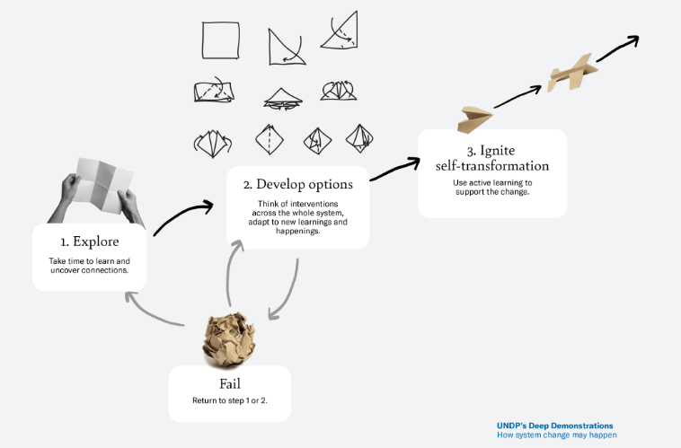

*Figure 7: “How to design a Portfolio through Practice?” Structure of a System Change (UNDP Unstuck website)*

The portfolio approach is a dynamic process fostering learning within human systems. It involves creating interconnected interventions that actively build community capabilities, relationships, and narratives through experiential learning. These portfolios enhance adaptive capacity, fostering systemic change known as self-transformation, empowering communities and societies to navigate uncertainties confidently. Exploration involves engaging stakeholders, uncovering connections, and building a shared vision within the context. Development of Options creates interventions stimulating different aspects of human systems and adapts outcomes to new learnings, aiming for self-transformation within the system. Ignition for Self-Transformation uses interventions as active learning experiences, building confidence and turning learning into policies and cooperation, ultimately building adaptive capabilities within human systems (UNDP, 2023) (UNDP, 2022) (UNDP Unstuck website)

**Sustainable Energy Hub’s portfolio approach for UNDP Energy Moonshot**:

UNDP has established internal monitoring systems to track collective progress toward achieving the Energy Moonshot. The Tracker analysis aims to identify direct and indirect beneficiaries across all active UNDP energy projects aligned with the 2022-2025 Strategic Plan. Led by the Sustainable Energy Hub, efforts are underway to monitor and map the UNDP's portfolio of 320 energy-related projects. These projects encompass a diverse range, including on-grid and off-grid renewable electricity, solar home systems, clean cooking, and support for e-mobility. A devised methodology converts project outputs into quantifiable measures for direct and indirect beneficiaries. This initiative aims to monitor the UNDP's progress, provide global energy-related data to UNDP Country Offices and the organization as a whole, foster collaboration with partners for collective efforts, and integrate the Energy Moonshot with other initiatives for a cohesive approach.

### Methods and Tools

This section explores key methodologies and tools that drive integrated actions for addressing interlinked SDG challenges. Methods offer structured procedures to achieve specific outcomes, while tools are the tangible resources facilitating method execution within an approach. A comprehensive overview of integrated mechanisms is provided to support Strategic Innovation. The Water-Food-Energy-Ecosystem Nexus, presented to exemplify the Nexus method, enhance a systemic analysis of specific SDGs interlinkages. Life Cycle Assessment provides a systemic perspective, accounting for socio-environmental impacts throughout initiatives' cycles. Multi-Criteria Decision Analysis methods aid in strategic multi-objective decision-making amid conflicting outcomes. Scenario Thinking visualizes outcomes from integrated strategies, while the Theory of Change operationalizes expected changes considering systemic interactions. These methodologies cover various aspects, from envisioning future scenarios to evaluating interventions and fostering ongoing learning and partnerships. The section also explores the landscape of opportunities within digital intelligence, leveraging Artificial Intelligence mechanisms and introducing key tools.

#### The Water-Energy-Food-Ecosystem Nexus

The WEFE Nexus, integrating water, energy, food, and ecosystems, fosters sustainable development by acknowledging their global and local interdependence and their impact on quantity, quality, and access. This approach promotes integrated solutions aligned with sustainable development goals, emphasizing efficient resource use and stakeholder dialogue for policy coherence across sectors and governments. Employing a decision-making framework grounded in systems thinking, it identifies cross-sectorial impacts, explores trade-offs, and guides development pathways towards resource efficiency, equity, and sustainability at various governance levels. Its versatility spans the project cycle, aiding in planning, design, implementation, monitoring, and evaluation. Stakeholder dialogues, scenarios, and response options drive this approach, facilitating integrated planning, decision-making, and cost-effective implementation. Methods range from qualitative indicators-based approaches to operational systems, chosen based on data availability, scale of impacts, stakeholder involvement, and communication needs. This assessment process enhances understanding of sector interactions, leading to optimal solutions feeding into policy dialogues, contingent on contextual factors, capacities, and constructive dialogues. Advantages include its ability to address interconnected challenges, develop comprehensive policy responses, and create integrated policies and practices addressing crosscutting challenges for both immediate needs and long-term goals. This approach leverages co-benefits, enhances resource productivity, resilience, and policy coherence, stimulating investments in sustainable infrastructure and ecosystem preservation (UNSGAB, 2014) (UNFCCC, 2015) (UNESCO, 2021) (SDG Asia Pacific, 2023) (UN et al., 2023) (Nexus, 2020).

**Framework: JRC & UNESCO’s WEFE Nexus Framework**

In 2018, the European Commission’s Joint Research Centre (JRC) and UNESCO’s Intergovernmental Hydrological Programme (IHP) initiated the "Water–Energy–Food–Ecosystems (WEFE) Nexus: Analyzing solutions for security supply" project amid water, energy, and food constraints.

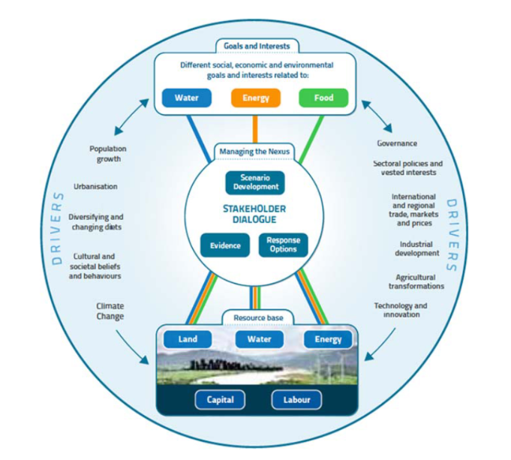

*Figure 8: UNESCO’s WEFE Nexus Framework (UNESCO, 2021)*

**Tools:** SDG Climate Action Nexus Tool; UNESCWA WEF Regional Policy Toolkit

**Indicators:** Water-Energy-and-Food-Security-Nexus Indicator

**Tool: UNESCWA Input-Output Analysis for Nexus Assessment**

Input-output analysis links economic, social, and environmental aspects of trade and investment, revealing resource usage impacts across production chains to final consumers. UNESCWA employs a modelling approach to estimate interlinkages among sustainable development goals, using a production function akin to input-output systems. The method yields interlinkage matrices, aiding the assessment of external variables' impact. Its advantages include the swift development of econometric models encompassing numerous indicators and data.

**Tool: International Science Council’s Tool for Mapping Nexus**

This guide visually analyzes SDG interactions, using a seven-point scale to quantify synergies and conflicts among goals and targets. Scores range from +3 (strong reinforcement) to -3 (conflict). Key dimensions like time, geography, governance, technology, and directionality define these interactions. The method generates an interaction matrix, visualized to assess how goals like Zero Hunger, Good Health, Affordable Clean Energy, and Life Below Water interact with others.

#### Life Cycle Assessment

Life Cycle Assessment (LCA) is a systematic method assessing the environmental impacts of a product or service throughout its life cycle, considering stages from extraction to disposal. It evaluates resource use, emissions, and social implications, aiding sustainability across SDGs. LCA informs decision-making, identifies improvement areas, and promotes sustainable practices. Its implementation involves defining goals, conducting inventory, assessing impacts, and interpreting results using specific tools. Integrated in early project stages, LCA guides design and development, ensuring environmental considerations from the start. The advantages include providing a holistic view, enabling informed decisions, identifying improvement areas, promoting sustainability, and allowing comparative analysis between options (RIT, 2020) (NREL, 2023) (UNEP, 2023) (Life Cycle Initiative, 2023).

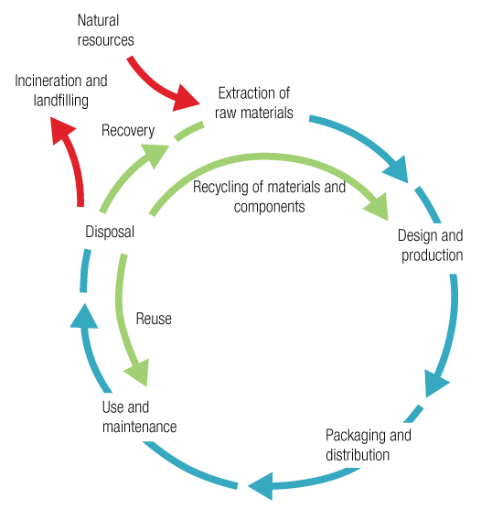

*Figure 9: Processes considered through the Life Cycle perspective (Life Cycle Initiative, 2023)*

#### Multi-Criteria Decision Analysis frameworks

Multi-Criteria Analysis (MCA) is a decision-making framework that evaluates alternatives influenced by diverse, conflicting factors. It integrates different metrics, particularly helpful for non-monetary impacts, aiding evaluations amidst conflicting objectives. Through individual criteria, it provides overall performance indicators for alternatives, allowing comparative assessments. By ranking options based on established criteria, MCA guides project evaluation and decision-making phases, offering insights into trade-offs among alternatives. Its strengths lie in enabling non-monetary impact comparison and systematically evaluating conflicting factors to identify stable solutions in complex decision problems (WB, 2023) (IAEA)

#### Scenario Thinking:

Scenario Thinking is a qualitative method visualizing plausible futures, providing narratives about potential developments in a specific region or issue. It's designed to explore diverse future possibilities amidst uncertainty and engages stakeholders in envisioning sustainable development pathways. This approach addresses complexity, encourages stakeholder collaboration, supports quantitative analysis, and creates compelling narratives about achieving sustainable development goals. Utilizing participatory exercises, it generates qualitative storylines, engages stakeholders, integrates sustainable development dimensions, and identifies short-/medium-/long-term effects of interventions. The outcomes involve narratives envisioning potential pathways for sustainable development, aiding stakeholders in envisioning multiple futures and addressing complex problems, fostering collaboration, supporting quantitative analysis, and offering engaging narratives about sustainable societies (UNESCAP, 2015) (SDGs UN, 2016).

#### Theory of Change

A Theory of Change method explains how interventions drive specific development changes based on causal analysis and evidence. It clarifies pathways from outputs to outcomes, aiding in planning and evaluating initiatives. This approach tackles complex problems, supports learning cycles, fosters partnerships, and acts as a concise communication tool. By outlining causal pathways, identifying needs and assumptions, and engaging partners, it helps understand and address underlying challenges. When applied to SDGs, it helps in understanding the interconnections between actions and impacts, aiding in the planning and evaluation of initiatives. The Theory of Change methodology involves a consultative and evidence-based approach, focusing on continuous learning and improvement while ensuring clarity and quality in program design and implementation. This method guides program design and fosters continuous learning and partnership development (UNEP, 2023)(UNICEF)(UNSDG).

**Case Study: Accès aux services énergétiques, Niger, UNDP**

#### Digital Intelligence: Machine Learning, Deep Learning and Artificial Intelligence

**Tool: Energy Moonshot AI Data Platform (UNDP)**

To bring clean energy to 500 million more people by 2025 and drive the shift to renewables, a fresh approach is vital. The Energy Moonshot AI Data Platform is breaking new ground, combining AI and geospatial data to offer unparalleled insights for energy projects worldwide. This tool empowers local action, tapping into global innovation. Refined by using cutting-edge technology, like Large Language Models, it supports technical officers and development efforts by providing energy insights. Automation features optimize project monitoring and reporting, offering live beneficiary updates. Through collaboration, this platform aims to seamlessly integrate AI advancements into energy policy and planning.

**Tool: SDG Push Diagnostic (UNDP)**

The UNDP's SDG Push initiative aims to drive COVID-recovery by exploring pathways toward achieving the SDGs by 2030. Their SDG Push Diagnostic offers reports from 94 countries, presenting development landscapes and policy choices made within fiscal constraints. This dynamic visualization tool integrates multiple data sources to analyze SDG trends, national priorities, and interlinkages, outlining potential pathways beyond 2030. It provides insights into challenges, growth trajectories, environmental sustainability, and inclusiveness (SDG Moment), aligns national priorities with SDGs using machine learning (Trends & Priorities), maps synergies and trade-offs for policy pathways (SDG Interlinkages), and offers fiscal insights and stimulus options for progress acceleration (Finance & Stimulus). This comprehensive approach leverages data, AI, and systems intelligence to support countries in accelerating progress toward the SDGs

**TAKE-HOME MESSAGES**

• Four approaches can revolutionize the way projects are designed, implemented, and evaluated, simultaneously addressing the world's primary challenges. System thinking views issues as interconnected systems rather than isolated parts, allowing a holistic understanding of the problems. Gender mainstreaming is the recipe for gender equality, necessitating the consideration of gender as an analytical variable throughout the project, program or policy cycle. A human rights-based approach ensures the fulfillment of people-centered goals, shifting the focus from basic needs to rights. The portfolio approach involves developing an interconnected network of interventions instead of isolated projects, promoting synergetic solutions and ensuring adaptability to uncertainties and resilience.

• Methods and tools serve as the operational backbone for nexus projects: Water-energy-food nexus methods are crucial for advancing water, food, and energy security simultaneously; Life cycle assessments allow viewing the entire system cycle for sustainable decision-making; Multi-criteria tools enable balancing conflicting criteria in the decision-making process, incorporating stakeholder perspectives; Scenario thinking visualizes the impacts of decisions; Theory of change articulates the steps driving desired changes; and Digital intelligence emerges as the tool for big data-driven decision-making, allowing accurate predictions and data patterns identification.

## Partnership and Collaboration for Development Financing

The previous section explored Sustainable Energy's links with other SDGs and integrated methodologies. SDG 7.a stresses funding and collaboration for clean energy, while SDG 17 underscores strengthening global partnerships for Sustainable Development. Enhanced partnerships accelerate SDG progress by leveraging synergies and avoiding trade-offs. Across contexts, organizations, and projects, international partnerships assume diverse roles in SDG implementation. They harness expertise and resources from international organizations, NGOs, governments, and the private sector, striving for faster, more effective, and equitable SDG achievement. Partnership forms include local implementation, resource mobilization, advocacy, policy development, lobbying, and market-based operations (IRENA, 2023). Partnerships are fundamental for catalyzing Sustainable Energy investment. The global sustainable development landscape's divergence necessitates immediate action to bridge the finance gap. Recent global crises expedite calls for reform in the international financial structure, urging rapid institutional change. Seizing this opportunity necessitates concerted efforts, emphasizing increased development cooperation, SDG investments, and fortified global financial architecture **(DESA, 2023)**. This chapter explores the Global Landscapes of Partnership and Financing for Sustainable Energy and SDGs interlinkages, offering strategies to leverage new collaborations and scale-up financing

### Partnership Ecosystems for Sustainable Energy and Integrated SDGs

UN-Energy, established by the UN System Chief Executives Board, is the United Nations’ mechanism for inter-agency collaboration on energy issues, aligning efforts to meet SDG 7 and support the 2030 Agenda and Paris Agreement. With 30 leading organizations globally and involvement in over 190 countries, it aims to promote coordinated policy development, implementation, and knowledge sharing (Figure 10).

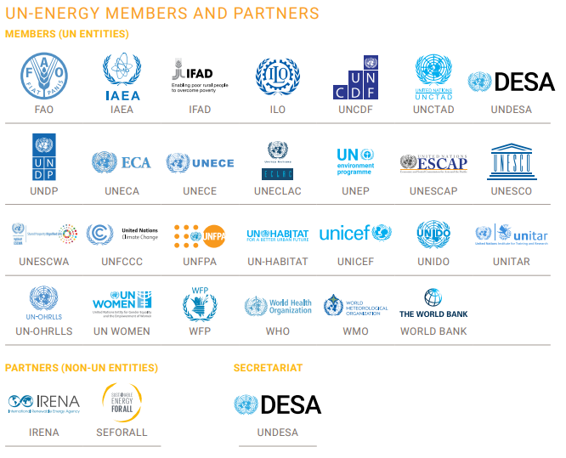

*Figure 10: UN-Energy members and partners*

A Global Roadmap for SDG 7 Action was developed following the UN Secretary-General's Dialogue on Energy, prioritizing energy access, decarbonization, finance, inclusivity, and innovation. This Roadmap will be achieved through over 200 Energy Compacts, translating commitments into concrete actions and partnerships. UN-Energy pledges to accelerate action through collaborative efforts, expanded partnerships, global campaigns, greener operations, forums, and tracking progress. Leveraging multi-stakeholder coalitions and bolstered capacity, UN-Energy aims to harness energy's potential for global sustainable development.

The Energy Compact Action Network by UN-Energy bolsters momentum, welcomes new stakeholders, fosters coalition-building, and drives continuous ambition and action, catalyzing necessary finance and investment. UN-Energy supports collective scaling through joint programs, amplifying UN collaboration, and Member State engagement. These programs focus on bridging the energy access gap, ensuring inclusive transitions, and integrating energy across sectors to achieve the SDGs. The urgent need for integrated approaches optimizing energy's impact on various sectors, ensuring equity in global energy transformation, and prioritizing gender inclusion calls for immediate action.

Strengthening inter-agency cooperation and leveraging data and digitalization for monitoring and communication of results remain central to their approach. Tracking progress through dynamic online platforms and indicators developed by advisory bodies ensures transparent and accountable reporting toward the milestones outlined in the Global Roadmap for SDGs. UN-Energy will compile a dynamic overview towards the milestones of the Global Roadmap, building on existing tools for tracking and monitoring, including Tracking SDG 7: The Energy Progress Report, the work of the SDG7 Technical Advisory Group (SDG7-TAG) and other relevant efforts. This will include establishing a dynamic online platform through which it will regularly provide updates on progress and activities undertaken. For instance, the SDG7-TAG advisory body developed a set of indicators for addressing Energy’s Interlinkages (SDGs UN, 2022).

**SDG 7 Technical Advisory Group (SDG7-TAG):** The SDG7-TAG stands as a multi-stakeholder coalition encompassing governments, UN agencies, civil society, the private sector, and diverse stakeholders, operating under the UN Department of Economic and Social Affairs. This group essentially serves as a collaborative body advising on strategies, analyses, and actions to accelerate progress towards achieving SDG7 and its interconnected goals. Through inclusive processes, policy briefs, and strategic recommendations, the SDG7-TAG aims to enhance the High-Level Political Forum's effectiveness, fostering partnerships and actions, providing analytical insights, overseeing the annual SDG7 Energy Tracking report, and advising on coordination efforts.

This section delves into the global landscape of multi-stakeholder alliances and platforms. It begins by introducing relevant compacts, coalitions, alliances, hubs, and public-private partnerships. It then highlights significant joint programs and inter-agency initiatives before concluding with key multi-stakeholder knowledge and data platforms.

#### Compacts, Coalitions, Alliances, Hubs and Public-Private Partnerships

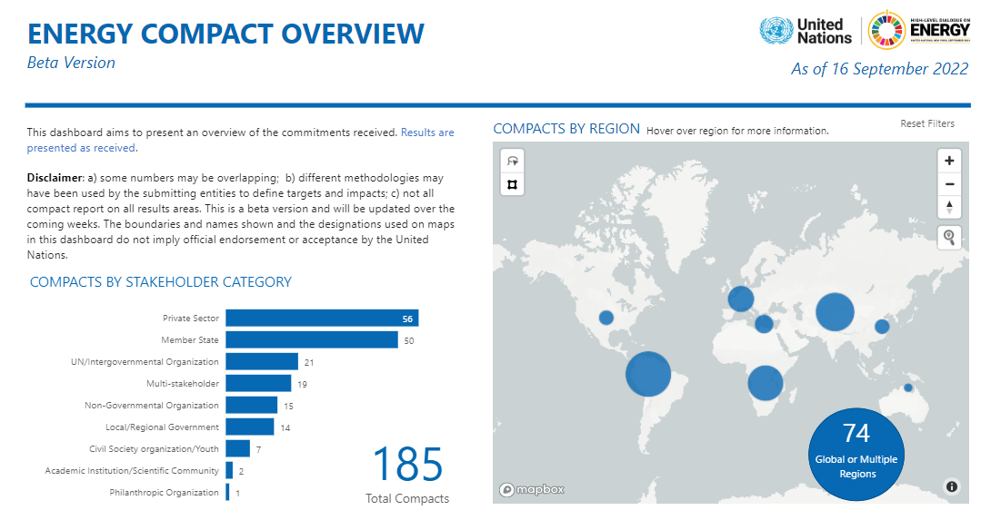

*Figure 11: Energy Compact Overview (UNDP, 2022)*

**United Nations Global Compact (UNGC**): The United Nations Global Compact (UNGC) is a significant initiative with over 9,500 companies and 3,000 non-business signatories across 160+ countries, spanning civil society, government bodies, investor groups, academia, and 70 local networks. It fosters responsible business practices by aligning strategies with ten core principles related to human rights, labor, environment, and anti-corruption. This voluntary effort encourages businesses to contribute to societal goals and the Sustainable Development Goals (SDGs), aiming to mobilize a global movement of responsible enterprises and drive actions for a sustainable world. The UNGC emphasizes multi-sectoral collaborations, transformative partnerships, and action platforms engaging diverse stakeholders to address complex challenges and achieve SDGs through scalable impacts and time-bound deliverables.

**Gender and Energy Compact:** The Gender and Energy Compact, led by ENERGIA, GWNET, and UNIDO, is a global coalition focused on advancing gender equality and women's empowerment in the context of a just, inclusive, and sustainable energy transition. Comprising stakeholders from governments, private sector, academia, civil society, youth, and international organizations, this coalition aims to achieve two core goals: ensuring women have equal opportunities to lead, participate in, and benefit from a sustainable energy transition, and granting women equal access to and control over sustainable energy products and services. Through joint commitments and individual Energy Compacts submitted by signatories, the Compact strives to eliminate energy and time poverty, foster gender-responsive energy policies, enhance women's entrepreneurship and career advancement, and promote gender-responsive knowledge and data availability by 2030. These efforts target the achievement of SDG7 on universal access to sustainable energy and SDG5 on gender equality through tangible outcomes, including increased resources for women-led businesses, improved employment opportunities, and more comprehensive data and tools for gender-responsive policy formulation and evaluation.

**UNDP’s Sustainable Energy Hub:** The UNDP Sustainable Energy Hub collaborates with governments, UN-Energy, member states, the private sector, and civil society to facilitate a just and sustainable energy transition. Their aim is to support countries in achieving SDG 7 by providing clean, affordable energy to an additional 500 million people by 2025. The Sustainable Energy Hub aims to mobilize partnerships to accelerate the low carbon transition and renewable energy revolution.

**Powering Healthcare Hub**: The Powering Healthcare Hub, driven by SEforALL and in collaboration with other stakeholders, aims to resolve the issue of inadequate or unreliable electricity access in healthcare facilities, impacting around one billion people globally. This initiative offers a centralized platform providing data, best practices, and leadership to facilitate the electrification of health facilities. It addresses the estimated requirement of USD 5 billion for electrifying health facilities in South Asia and Sub-Saharan Africa, integrating innovative technologies and business models. SEforALL's Powering Healthcare program underpins this initiative, empowering governments and development partners with evidence and solutions to achieve sustainable electrification of health facilities by 2030. The program aims to inspire stronger commitments, increase investments, and enhance the sustainability of interventions, contributing to universal, sustainable electrification in the healthcare sector.

**Global Interventions Map**: The Global Interventions database provides a one-stop sectoral overview of the work happening around the world to electrify healthcare facilities, and aids stakeholders in identifying opportunities for coordination and collaboration.

**Global Alliance for Clean Cookstoves**: The Global Alliance for Clean Cookstoves, hosted by the UN Foundation, is a public-private partnership uniting over 1300 partners from governments, multilateral organizations, the private sector, NGOs, academia, and philanthropy. Established to create a thriving market for clean household cooking solutions, its objectives include saving lives, enhancing livelihoods, and preserving the environment, recognizing particularly the impact on women due to traditional cooking methods. Focused on promoting clean and efficient cooking (SDG7) and empowering women by reducing their exposure to indoor air pollution (SDG5), the Alliance seeks to reach 100 million households by 2020. To achieve this, it concentrates on catalyzing the sector, attracting investments, advocating for change, setting standards, conducting research, and advocating globally. This partnership addresses global needs, prioritizes market-based solutions, and coordinates a comprehensive strategy for clean cooking solutions' widespread adoption, emphasizing accessibility and sustainability. This alliance has developed an “Introductory Framework for Measurement, Reporting, and Verification for Clean Cooking Energy Initiatives” (links)

**Global Platform for Action (GPA) on Sustainable Energy in Displacement Settings:** The Global Platform for Action (GPA) on Sustainable Energy in Displacement Settings operates as a united effort hosted by UNITAR to ensure sustainable energy access in humanitarian contexts. It collaborates with energy, development, and humanitarian partners to transition towards renewable energy, aiming to improve efficiency, reduce costs, and cut emissions. GPA focuses on local solutions, gender sensitivity, and financial sustainability across five thematic areas. Engaging displaced persons, host communities, governments, and humanitarian agencies, it aims to devise context-specific solutions for collective change in energy access for crisis-affected communities. The GPA is guided by a coalition of UN and international bodies, including UNITAR, UNHCR, IOM, GIZ, WFP, FAO, UNEP, UNDP, Chatham House, Practical Action, Clean Cooking Alliance, Mercy Corps, Sustainable Energy for All, SNV, Lifeline Fund, and MECS and receives support from the Federal Foreign Office of Germany, Norway, NORCAP, and MECS.

**Partnership for Action on Green Economy (PAGE):** PAGE, comprising five UN agencies (UNEP, ILO, UNDP, UNIDO, UNITAR), funding partners, and partner countries, focuses on transforming economies into drivers of sustainability. Since 2013, it embeds lasting changes in national policies, providing integrated support to reduce poverty, enhance social equity, and promote environmental stewardship while sustaining economic growth. With a vision challenging current economic trajectories, it aims to achieve global sustainability goals by reframing economic policies, fostering collaborations, and informing policy debates. The partnership's activities involve supporting countries at different policy development stages, managing substantial funding, engaging UN agencies for expertise, and collaborating with various action partners for effective outcomes.

**Better Than Cash Alliance:** The Better Than Cash Alliance, housed within the United Nations, comprises governments, corporations, and global entities committed to expediting the transition from cash to responsible digital payments to drive the Sustainable Development Goals. With 80 members, including national governments from Africa, Asia-Pacific, and Latin America, as well as global brands and humanitarian NGOs, the alliance advocates for digitizing payments to enhance efficiency, transparency, and women's economic participation. By providing advisory services, sharing research, and fostering peer learning, it aims to ensure that digital payment options surpass cash in terms of responsibility, inclusivity, and efficiency, acknowledging the importance of cash while advocating for secure and empowering digital alternatives.

**UN Office for Partnership:** The United Nations Office for Partnerships (UN Partnerships) operates as a global hub for fostering partnerships to drive SDGs. Through the Executive Director's office, SDG Advocates, Strategy Hub, climate action mobilization, UNDEF, and UNFIP, it engages stakeholders globally, enhancing coordination and accountability towards achieving SDGs. The Advocates leverage their influential positions to drive transformative change, while the Strategy Hub collaborates across sectors for SDG activations. Climate action mobilization focuses on ambitious climate goals, while UNDEF and UNFIP empower civil society and facilitate cross-sector initiatives, respectively, contributing to a comprehensive approach for sustainable development.

#### Joint Programs and Inter-agencies Initiatives

**The Giga initiative**: Giga aims to connect every school globally by 2030, leveraging UNICEF’s educational expertise, ITU’s regulatory knowledge, and private sector tech solutions. It maps schools and connectivity levels, utilizing machine learning for real-time mapping, aiding funders, governments, and ensuring accountability. This initiative stands out in the UN Secretary-General’s Digital Cooperation Roadmap and Common Agenda, emphasizing its significance. Mapping schools allows effective resource allocation, guides emergency response efforts and ensures quality internet access, addressing data inequity and highlighting infrastructure gaps for better investment opportunities. Giga ultimately aims to establish market demand, encouraging internet service providers to expand infrastructure to remote areas, reducing disparities and fostering global connectivity.

**United for Efficiency:** The United for Efficiency (U4E) initiative, under the leadership of the United Nations Environment Programme (UNEP), spearheads a global effort focused on aiding developing nations and emerging economies in transitioning towards energy-efficient appliances and equipment. U4E operates through a multi-stakeholder approach, collaborating with diverse partners, including UNEP, the Global Environment Facility (GEF), UNDP, industry leaders like the International Copper Association (ICA), CLASP, and NRDC. This initiative's primary objectives involve informing policymakers about the benefits of high-efficiency products, promoting best practices, offering tailored assistance to governments in developing and implementing strategies, and extending its scope beyond efficient lighting to encompass various high-efficiency products. U4E's core emphasis lies in reducing global electricity demand, mitigating climate change, and enhancing quality of life by optimizing energy usage. Its comprehensive approach addresses electricity wastage, pollution, and greenhouse gases, offering financial grants, policy guides, national market transformation projects, and capacity-building workshops across various regions, engaging over 60 partners globally. Academic institutions, industry leaders, and international organizations are part of this collaborative effort, supporting countries in their transition to sustainable, energy-efficient products to yield significant economic and environmental benefits.

#### Multi-Stakeholders Knowledge and Data Platforms

**Global Partnership for Sustainable Development Data (GPSDD):** The Global Partnership for Sustainable Development Data is a vast network comprising over 700 organizations spanning private sectors, academia, civil society, and governments worldwide. Operating across 35+ countries with a network in 80+, its primary focus is leveraging the transformative potential of data to drive change aligned with the Sustainable Development Goals (SDGs). By advocating for inclusive, timely, and well-governed data, the partnership aims to empower governments to make informed decisions and policies. Their strategic approach involves boosting data use through multi-stakeholder collaborations, addressing challenges like limited data access and analytical capacity. Their goal is to ensure marginalized groups have representation in data processes while promoting accountable data governance as a standard practice, all with the ultimate aim of accelerating SDG progress and fostering impactful global change.

**UN Sustainable Development Group:** The UN Sustainable Development Group (UNSDG) operates globally as a critical forum driving joint policies, decisions, and investments in line with the 2030 Agenda for Sustainable Development and its 17 goals. Covering 162 countries and territories, this body oversees and coordinates UN efforts worldwide for sustainable development. It translates global decisions into actionable initiatives at the country level, as showcased through the UNSDG Data portal (UNINFO). Furthermore, at the regional level, the five Regional Collaborative Platforms (RCP) unify all UN entities, chaired by the Deputy Secretary-General and co-chaired by key representatives from Regional Economic Commissions and the United Nations Development Programme (UNDP). These RCPs concentrate on cross-border challenges, pooling expertise to cater to the specific needs of each region while reinforcing coordination between UN entities and supporting country-level work conducted by Resident Coordinators and UN country teams. For instance, the UNESCAP and the Asia-Pacific UN Development Coordination Office, have led in consultation with the UNSDG the Asia-Pacific Knowledge Management Hub.

**UNINFO, UNSDG Data Portal**: Managed by the UN Development Coordination Office (DCO), the portal showcases country-level UN programming, including new Sustainable Development Cooperation Frameworks and previous UN Development Assistance Frameworks. Users can access country-specific summaries and comprehensive information about the UN Country Team's work via filters and menu options. Overseeing sustainable development across 162 countries, UNSDG's data portal, UNINFO, offers valuable insights into translating global decisions into actionable progress at the country level.

**Asia-Pacific Knowledge Management Hub**: The Asia-Pacific Knowledge Management Hub, spearheaded by UNESCAP and the Asia-Pacific UN Development Coordination Office, stands as a centralized platform aggregating policy expertise across sectors. This initiative aims to streamline access to knowledge resources, SDG-related data, tools, and educational materials, facilitating countries and country teams in identifying and responding to emerging national needs aligned with the 2030 Agenda. Functioning in close coordination with the regional UN Sustainable Development Group, the Hub acts as a repository for SDG-related information, offering a gateway to regional statistical data, while also providing access to a network of expertise and practitioners dedicated to supporting the effective implementation of sustainable development initiatives.

**UN Sustainable Development Solutions Network (SDSN):** The UN Sustainable Development Solutions Network (SDSN), established in 2012, operates under the UN Secretary-General to engage universities, think tanks, and laboratories in advancing the Sustainable Development Goals (SDGs) and Paris Agreement objectives. This network mobilizes academia, civil society, UN agencies, and the private sector to translate scientific evidence into actionable solutions for sustainable development.  As of 2023, the SDSN has over 1,800 members in 50+ networks across more than 145 countries. It serves as an educational and research alliance, facilitating global cooperation, producing vital research reports such as the [Sustainable Development Report](https://www.sdgindex.org/). SDSN's vision involves empowering societies through free online education (SDG Academy) and aims to accelerate SDG progress through academic expertise, research contributions, policy analysis, and global collaboration. The SDSN Climate & Energy Program is advancing technological developments and innovative practices to achieve energy systems decarbonization.

**SDSN Climate & Energy Program**: The purpose of the SDSN Climate & Energy Program is to bolster the capacity of UNFCCC signatory nations in formulating and executing long-term low greenhouse gas emissions strategies (NDCs and LEDSs) as stipulated by the Paris Agreement. It aims to develop 2050 strategies for decarbonized energy systems through public-private collaborations, foster a global dialogue among engineers and tech experts for innovative carbon-neutral solutions, and facilitate international partnerships for technological solutions involving governments, businesses, academia, and civil society. This program seeks to empower nations in achieving the goals outlined in the Paris Agreement by enhancing technical capabilities, encouraging innovation, and promoting collaborative efforts across various sectors.

### Establishing Effective Partnerships and Collaboration

This section delves into two essential strategies for fostering partnership and collaboration. Initially, it provides insights into constructing and efficiently managing multi-stakeholder partnerships aimed at addressing various SDGs. Following this, it examines methodological considerations for developing Joint Programs in a multi-stakeholder environment. UN leaders from UNDP, UNFPA, UNIDO, and UN Women have emphasized the imperative need for rapid scaling up of cross-sector partnerships to expedite progress on the Sustainable Development Goals (Accenture, 2018).

#### Building and Managing Effective Multi-Stakeholder Partnerships for SDG Progress

The 2030 Agenda Partnership Accelerator, led by UN DESA and The Partnering Initiative, in collaboration with UNOP, UN Global Compact, and UN Development Coordination Office, aims to expedite multi-stakeholder partnerships for the Sustainable Development Goals (SDGs). It offers training, advisory services, and capacity building to member States, UN entities, and country teams to strengthen collaboration across sectors, foster new partnerships, and establish effective platforms at the national level. Its objectives include establishing partnerships, enhancing skills for SDG-focused collaborations, and promoting collaboration between diverse stakeholders to boost engagement and implementation of the SDGs. The Partnership Accelerator offers a network of individuals committed to building effective multi-stakeholder partnerships for the Sustainable Development Goals (Accelerators) and a **Partnership Learning Centre** including modules on how to build and manage effective multi-stakeholder partnerships to advance the SDGs.

Building and managing effective multi-stakeholder partnerships to advance the SDGs requires the following steps:

* **Creating Collaboration Space**: Establish an environment conducive to collaboration, integrating policies, catalytic platforms, high partnership standards, institutionally adept organizations, and skilled individuals for fruitful partnerships.
* **Partnerships for SDGs**: Embrace the 2030 Agenda, emphasizing the need for significant changes in international development, fostering systematic collaboration among sectors, and elevating partnerships as pivotal for SDG-aligned progress.
* **Private Sector Engagement**: Understand the private sector's role, incentives, potential conflicts of interest, and its alignment with development goals.
* **Defining Partnerships**: Clarify the spectrum of partnerships for the SDGs, strategic planning, and categorization.
* **Understanding Stakeholders**: Adopt a creative thinking approach in identifying stakeholders and resources.
* **Maximizing Partnership Value**: Ensure every partnership generates net value for each partner through the Collaborative Advantage and maximize partnership value through negotiation.
* **Partnership Lifecycle**: Understand the different stages of partnerships from initiation to conclusion.
* **Effective Partnership Building Blocks**: Focus on fundamentals, partnership relationships, structuring, and management as the key building blocks for successful partnerships.
* **Institutional Readiness**: Overcome internal obstacles within organizations, addressing strategic, systemic, capacity, and cultural challenges to amplify partnership ambitions.

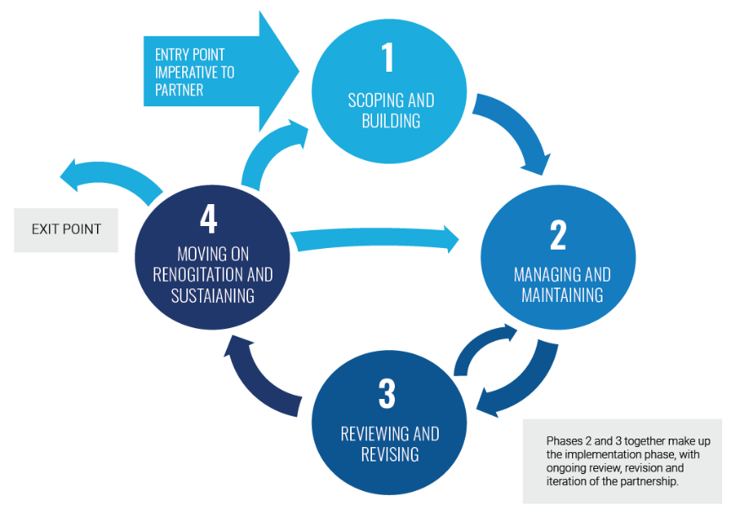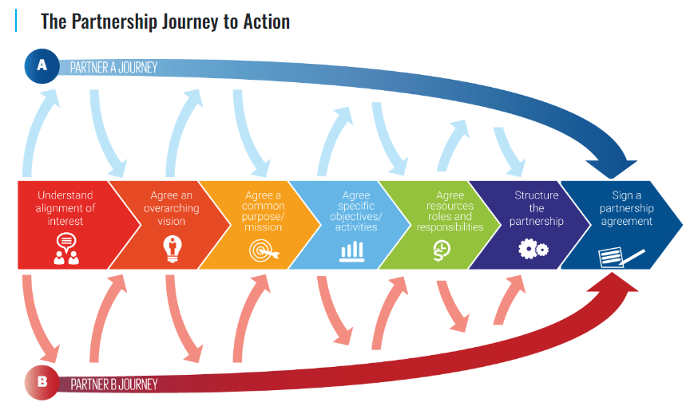

*Figure 12. The Partnership Life Cycle and the Partnership Journey to Action (DESA & TPI)*

#### Developing Joint Programs

The Guidance Note on a New Generation of Joint Programs, developed by the The United Nations Sustainable Development Group (UNSDG), is intended to make joint programs (JP) more effective, catalytic, and easier to use. It responds to guidance and decisions by members states, lessons from experience, and needs identified by UN Country Teams. The guidance aims to enhance Joint Programs (JPs) within the **Cooperation Framework**, emphasizing key aspects like catalyzing policy changes, government ownership, aligned roles and responsibilities, quality standards, and joint management for results. It introduces options for flexible JP design and non-UN partner involvement, aiming to improve effectiveness and attract increased donor investment in support of the SDGs across all UN funds, programs, and specialized agencies.

**United Nations Sustainable Development Cooperation Framework**: The 2030 Agenda emphasizes a responsive UN development system, encapsulated in the new Internal Guidance for the UN Sustainable Development Cooperation Framework. These frameworks focus on four key objectives: aligning responses to national priorities for SDG achievement, fostering diverse partnerships across sectors and stakeholders, ensuring no one is left behind, and tailoring approaches to each Member State's needs. The Cooperation Framework now guides the entire program cycle, driving planning, implementation, monitoring, reporting and evaluation of collective UN support for achieving the 2030 Agenda. By emphasizing inclusivity, partnerships, and tailored responses, these frameworks aim to drive concrete actions on the ground, leveraging the UN system's collective capabilities to realize the 2030 Agenda globally.

A joint program is a strategic collaboration between two or more UN organizations and partners aimed at achieving significant development outcomes. It leverages the strengths of participating entities to deliver results aligned with country priorities, Sustainable Development Goals (SDGs), and Cooperation Framework objectives. These programs focus on policy changes that can drive systemic impact and may operate at country, regional, or global levels, involving multiple regions or countries. To implement a JP, key steps involve verifying its suitability, defining responsibilities across the JP cycle stages (Design, Implement & Adjust, Learn, Transition, and Close), and ensuring adherence to standard program cycles and quality standards aligned with the Cooperation Framework.

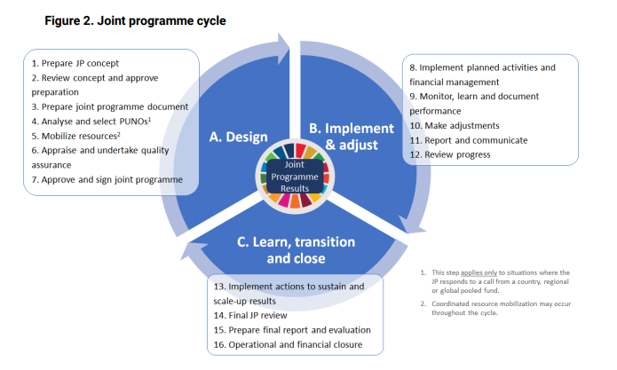

*Figure 13. Joint Program Cycle (UNSDG, 2022)*

To understand this cycle within a specific sector, a practical example to be considered is the UN-Habitat **Guidance for Multi-Partner Initiatives from the Global Future Cities Program.**

**Example: Partnering for Transformative SDG-Oriented Urban Development, Guidance for Multi-Partner Initiatives from the Global Future Cities Program, UN-Habitat**

Based on experiences from the Global Future Cities Program (GFCP), this report provides guidance to international donors, city authorities, UN agencies, and delivery partners about how to design and run multi-partner urban development initiatives that drive transformative impact and accelerate SDG implementation in rapidly urbanizing cities.

### Financial Mechanism for Integrated SDGs Achievement

Optimized financing has the potential to unlock substantial savings. Initiatives such as the Africa Minigrids Program showcase the potential of kickstarting large-scale private investments by developing early-stage minigrid markets. This section explores financial mechanisms for achieving integrated SDGs. It begins by examining the evolving financial landscape within the new investment paradigm, discussing shifts and trends influencing investment priorities. It then spotlights emerging financial solutions and opportunities that can drive sustainable development efforts. Additionally, it explores diverse financing frameworks, platforms, and tools available to support the realization of SDGs.

**SDG Finance in Energy: The Africa Minigrids Program (AMP)**

The Africa Minigrids Program (AMP) operates in 21 African countries, focusing on early-stage minigrid markets to enable subsequent large-scale private investments. AMP aims to enhance clean energy access by boosting the financial viability of renewable energy minigrids, emphasizing cost reduction (hardware, soft, and financing costs) and innovative business models. These efforts intend to lower tariffs and expand services for end-users. This multi-partner initiative involves UNDP, the Rocky Mountain Institute, and the African Development Bank, funded by GEF. Collaborating with various stakeholders, AMP supplements existing efforts in the minigrid space, fostering partnerships and cooperation. Launched in 2022, AMP is scheduled to run until 2027.

#### The Collaborative Financial Landscape

**Joint SDG Fund:** The Joint SDG Fund operates as a multi-partner trust fund supporting broader UN functions in a flexible and multilateral-friendly manner. It aims to mobilize $290 million annually for SDG-focused development programs, having funded 230 joint initiatives across 119 countries and territories. With partners including UN Member States, international organizations, the private sector, and philanthropists, it has generated over 1,000 partnerships and tested 300+ innovative solutions for the 2030 Agenda. In 2022, it finalized 35 integrated programs, attracted $2.3 billion in additional financing alongside its $258 million commitments, achieving a leverage of over $9 for every $1, fostering an environment for SDG-driven policies. This effort prioritizes two outcomes: Accelerating SDG Achievement Through Integrated Policies and Amplifying Finance for Transformative Change. A thematic focus on Climate Action and Energy Transformation, engaging with UNFCCC and stakeholders, emphasized the implementation of climate programs, amounting to $83 million in commitments, positioning the Fund as a COP financing solution.

**Global Impact Investing Network (GIIN):** The Global Impact Investing Network (GIIN) serves as a global advocate for impact investing, striving to enhance its global effectiveness. Through collaboration with investors, the GIIN facilitates knowledge exchange, promotes innovation, and provides resources to reduce barriers to impact investment, directing more capital toward global challenges. Its strategy includes networking, alliances, events, impact measurement tools, research initiatives, and market leadership programs. Engaging with strategic partners like the Asian Venture Philanthropy Network, the GIIN aims to build an ecosystem that fosters impactful investing, contributing to a more equitable and sustainable world.

**Partnership Fund for the Sustainable Development Goals:** The Partnership Fund for the Sustainable Development Goals, led by the World Bank Group, aligns with SDG 17 to bolster global partnerships for sustainable development. Established in 2018, it channels seed funding to strategic, high-impact initiatives aimed at fostering an enabling environment for investment, innovation, and scalable solutions. With three core objectives—strengthening capacity for SDG implementation, developing analytical tools, and fostering multi-stakeholder partnerships—the Fund collaborates with over 400 partners, including UN agencies, private entities, academia, and civil society. The Partnership Fund for SDG has supported the implementation of Panama’s Energy Transition Agenda by assisting the Government of Panama with the preliminary design of the Energy Transition Fund (FTE) and the preparation of a WB guarantee operation to help capitalize the fund.

**Design Support for the Energy Transition Fund in Panama:** Led by Panama's National Secretariat of Energy (SNE), the FTE will drive action plans for the country's energy transition. Additionally, this initiative fosters international experience in fund design and capacity-building in SNE, with plans for replication in Central America, including Costa Rica, El Salvador, and the Dominican Republic. Notably, the FTE will focus on solar systems for subsidized households and credit lines for solar systems and efficient equipment in non-subsidized homes, enabling preferential loans for installing solar panels and energy-efficient appliances.

**UN Capital Development Fund (UNCDF):** The UN Capital Development Fund (UNCDF), created by the UN General Assembly, aids developing nations by offering grants and loans. Focused on Least Developed Countries (LDCs), it operates autonomously under the UN Development Programme and collaborates with member states and partners. UNCDF targets sustainable growth aligned with global agendas, emphasizing partnerships, inclusive finance, and leveraging public-private resources. Its main aim is to assist LDCs facing crises and challenges like COVID-19 and climate change, deploying capital strategically across key areas for transformative economic growth from 2022-2025.

**Inter-agency Task Force on Financing for Development (IATF**): The Inter-Agency Task Force on Financing for Development, comprising over 60 UN agencies, coordinates efforts to implement the Addis Ababa Action Agenda. Led by Mr. Li Junhua, it advises on sustainable development financing, providing annual reports to ECOSOC. Its mandate includes analyzing global contexts, highlighting synergies within the Addis Agenda, and addressing thematic issues, aiming to guide progress and recommend corrective actions at national and regional levels. This information is synthetized into Financing for Sustainable Development Report. This collaboration among international institutions ensures effective follow-up on financing for sustainable development.

#### Emerging Financial Solutions and Opportunities

Various innovative financing solutions are emerging to address specific development challenges. (UNDP, 2018) (G20, 2022)

**Scaling up blended finance and de-risking facilities:** Blended finance, including de-risking facilities, creatively combines public, private, and philanthropic funds to tackle development challenges. It leverages public resources to attract private investment, maximizing impact. By mitigating risk for private investors, it encourages their involvement in projects that might not have been feasible otherwise. This approach aligns diverse interests and capitalizes on the strengths of various sectors to achieve sustainable development goals. Blending practices vary across institutions, including the use of concessional and non-concessional public finance from MDBs, other Development Finance Institutions (DFIs) and development aid programs, and to a lesser extent, donors and other third parties. A key benefit of blended finance mechanisms, as opposed to purely public finance, is that it crowds in private capital and can expand the total amount of sustainable finance available and thereby improve the affordability and accessibility of sustainable finance. It can also operate as a mechanism to create sustainable markets by being the initial finance that allows a market or sector to develop.

**Developing and deploying digital technologies:** The utilization of digital technologies presents a transformative opportunity in sustainable finance and inclusive development. These technologies significantly reduce the expenses related to data collection, assessment, and reporting, enabling the identification of sustainable assets and the disclosure of crucial ESG information. However, challenges persist, especially for sectors like agriculture and tourism in developing economies, where data collection remains costly. Emerging technologies hold promise in easing this burden, particularly for SMEs, potentially granting them easier access to sustainable finance. Additionally, financial technologies like mobile payment systems have notably expanded financial services, particularly benefiting rural populations globally. Recently, digital tools have been instrumental in gathering granular ESG data, implementing Sustainable Supply Chain Financing (including Fintech tools such as digital platforms and blockchain-based technologies), and managing sustainable assets.

**Impact Investing:** Impact investing aligns financial goals with social and environmental impact. Investors actively seek opportunities that generate positive, measurable outcomes alongside financial returns. This approach drives capital towards businesses and projects that address pressing social and environmental challenges, ensuring a more sustainable and equitable future. Impact investing is a burgeoning solution, combining social and environmental impact with financial returns globally. Key aspects involve intentional positive impact, expected financial returns, and diverse return rates across various assets. Robust impact measurement is pivotal for transparency. It offers opportunities for investors to support societal causes while gaining financial returns. Various entities, from financial institutions to governments, leverage it for diverse reasons, attracting a broad spectrum of investors. Financial performance varies, with some seeking below-market returns aligned with goals, while others aim for competitive, market-rate returns. A handful of impact investors have begun to create products, raise capital, and make new investments that directly target progress toward the SDGs. Going beyond aligning and retroactively mapping impact to the SDGs, these investors proactively target and incorporate the goals at various stages of the investment cycle, thus making them the central focus.

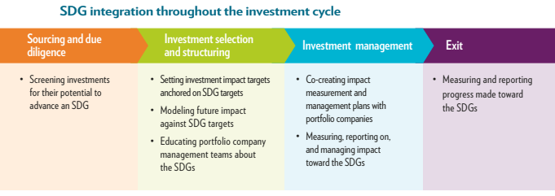

*Figure 14. SDG integration throughout the investment cycle (GIIN, 2018)*

**Partners Group PG Life Strategy**: Partners Group introduced PG LIFE to meet client demands for investments in line with UN SDGs, focusing on healthcare, education, and clean energy. Operating across private markets for pension and sovereign wealth funds, it uses an Impact Committee and an external LIFE Council to ensure SDG alignment. The strategy integrates SDGs at every investment stage, from sourcing to management, emphasizing impact metrics post-investment. An investment example, Techem, offers heat and water sub-metering services, reducing utility costs in Europe, UAE, Turkey, and Brazil, aligning with SDG 6 and 7 by enhancing energy and water efficiency, also leading to substantial CO2 emission reductions.

**Budgeting for SDGs (B4SDG):** Budgeting for Sustainable Development Goals (B4SDG) involves integrating SDGs into public finance and fiscal planning, championed by UNDP. It supports strategic budgeting, enabling SDG integration into frameworks, classification systems, and fostering public engagement for accountability. This process aligns with countries’ efforts to meet the 2030 Agenda, incorporating 17 universal SDGs with 169 targets. B4SDG facilitates the translation of high-level policies into budget decisions, enhancing efficiency, equity, and effectiveness in achieving SDGs. The steps entail contextual analysis, reviewing the public financial management system, assessing institutions, modeling the most relevant tools for reforms, and formulating reform offers. Through these efforts, B4SDG aims to bridge policy and budget systems, ensuring coherence, transparency, and accountability, essential for SDG implementation. This initiative caters to UN agencies and national governments, aiding in SDG mainstreaming, planning, and budgeting processes, contributing significantly to the Integrated National Financing Frameworks (INFFs).

#### Financing Frameworks, Platforms and Tools

**UNDP Sustainable Finance Hub (SFH):** The Sustainable Finance Hub (SFH), spearheaded by the United Nations Development Programme (UNDP), is a strategic initiative aimed at catalyzing finance for the SDGs. The SFH engages governments, civil society, and the private sector to prioritize SDG-aligned investments. This initiative facilitates access to private investors, designs innovative financial instruments, supports national financing frameworks, and fosters knowledge sharing on sustainable finance practices. Collaborations span UNDP Country Offices, the Istanbul International Center for Private Sector in Development (IICPSD), international financial institutions, business leaders, faith-based finance partners, and UN agencies like UNDESA, UNICEF, UN Women, and UNCDF. The overarching goal is to establish an inclusive economic governance architecture that mobilizes substantial resources towards the $1 trillion ‘Moonshot’ target for the SDGs, driving systemic reforms and enhancing alignment and capacity for sustainable finance. The UNDP's Sustainable Finance Service offers a 4+1 solution including: Public Finance, Unlocking Private Capital for SDG alignment, SDG Impact Management & Finance Tracking, Integrated National Financing Frameworks (INFFs) & Portfolios, and the **SDG Finance Academy**.

**UNDP’s SDG Finance Academy:** The SDG Finance Academy, launched by the Sustainable Finance Hub, aims to achieve the $1 trillion SDG target. This Academy offers comprehensive training across four core areas: Public Finance, Private Capital Alignment, SDG Impact Management, and National Financing Frameworks. Tailored for UNDP staff in 170 countries and external stakeholders, it provides knowledge on financial tools, their alignment with SDGs, implications for policy reform, and customization for national development needs. The Academy operates through learning sessions, community building, expert curation, and engagement facilitation and offers customizable training for public and private sectors, emphasizing the interconnectedness of SDG finance principles.

Parte superior do formulário

**SDG Investor Platform:** The SDG Investor Platform, led by the United Nations Development Programme (UNDP) in partnership with the Global Investors for Sustainable Development (GISD) Alliance, acts as a comprehensive resource offering crucial data and insights for investors to direct capital towards Sustainable Development Goals (SDGs). By employing a rigorous methodology rooted in extensive research and stakeholder input, it identifies global investment opportunities aligned with SDGs. Leveraging partnerships with specialized partners and UNDP Country Offices, the platform provides localized investment and impact data, aiding comprehensive understanding. Its goal is to empower investors with the necessary tools to drive capital towards SDGs while assisting countries in securing vital post-COVID-19 financing for advancement, ultimately benefiting both human well-being and environmental sustainability. The platform integrates UNDP’s **SDG investor Map,** a country-specific market intelligence tool that translates SDG needs and policy priorities into actionable investment opportunity areas.

**SDG Investor Map:** The SDG Investor Maps are country-specific tools developed by the United Nations Development Programme (UNDP) to bridge the gap between interest and investment in Sustainable Development Goals (SDGs). These innovative maps employ a rigorous eight-step methodology involving comprehensive desk research and consultations with public and private sectors within countries. By identifying overlaps between development needs and policy priorities, these maps validate potential impactful and investable business models. The goal is to transform SDG needs and policy priorities into actionable investment opportunities, directing capital towards emerging markets where SDG priorities align with government policies and market opportunities.

**Integrated National Financing Framework (INFF):** The Integrated National Financing Frameworks (INFFs) are a mechanism designed to finance national sustainable development priorities and operationalize the Addis Ababa Action Agenda at the country level. They serve as a planning and delivery tool, bridging the gap between a country's sustainable development strategy and the means to finance and implement it, utilizing diverse public and private financing sources. INFFs aim to bolster planning processes, surmount obstacles, and mobilize resources—both domestic and global—to support sustainable development and the SDGs. These frameworks essentially guide the financing of national strategies and prioritize the accomplishment of the 2030 Agenda and its 17 SDGs. INFFs operate via four essential building blocks: assessment and diagnostics, financing strategy, monitoring and review, governance, and coordination. These blocks collectively enhance a nation's ability to strategically plan and manage sustainable development financing. Activities within each block iteratively reinforce progress in others, leveraging existing structures and mechanisms within national frameworks. While the core components remain constant, actions within these blocks vary by country, culminating in an INFF tailored to each nation's distinct capacities, vulnerabilities, and priorities. INFF are fostering integrated financing solutions advancing toward sustainable energy and other SDGs’ interlinkages in Tanzania and Azerbaijan.

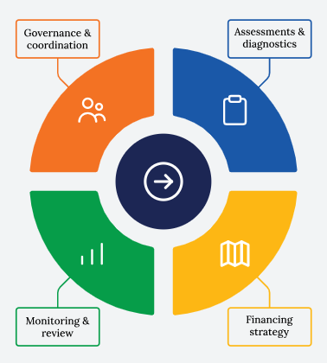

*Figure 15. The INFF building blocks (INFF website)*

**Mobilizing private finance through INFF:**

In Tanzania, INFFs are driving private investment by identifying SDG-aligned opportunities across sectors like agriculture, education, and renewable energy. Thirteen investment opportunity areas (IOAs) have been pinpointed, attracting investments in solar solutions for community systems and empowering rural women through edible oil crop farming.

In Azerbaijan, the INFF focuses on reducing fossil fuel dependence by steering investments toward green energy and sustainable agriculture. The government aims to collaborate with the private sector and global community to reshape policies, scale up SDG programs, and transition to a green growth economy, mitigating inequalities and environmental risks tied to the extractive industry.

**Climate Investment Platform:** The Climate Investment Platform (CIP), led by IRENA in collaboration with UNDP, SEforALL, and GCF, aims to bolster renewable energy impact investing in developing nations. It offers tailored technical assistance and finance matchmaking to advance renewable energy technologies. The platform invites renewable energy projects aligned with SDGs and national climate priorities to seek support beyond conceptual stages. CIP's Investment Forums, organized around sub-regional clusters, focus on project pipeline development and dialogue fostering improved investment conditions. These forums aim to enhance bankable proposals, facilitate investment matchmaking, and encourage dialogue for better investment frameworks. The platform's strategic approach includes continuous support for projects attracting investor interest and capacity building for policy enhancement and technical areas, aiming to fortify renewable energy landscapes in developing countries.

**Development Finance Assessment (DFA) tool:** The Development Finance Assessment (DFA) tool, led by the United Nations Development Programme (UNDP), serves as a multi-stakeholder mechanism addressing the complex challenge of financing the Sustainable Development Goals (SDGs). It aims to mobilize additional resources and optimize existing funds for sustainable development. The DFA operates as a government-led process, engaging various stakeholders from governments, private sectors, NGOs, and international financial institutions. Its analytical framework evaluates and enhances integrated planning and financing functions, fostering public-private collaboration and accountability. Through this approach, the DFA aims to bridge the gap between national planning and finance policies, fostering consensus-driven solutions and creating roadmaps for achieving SDGs. UNDP’s comprehensive guidebook supports countries in this endeavor, providing a structured approach for officials, UNDP offices, and diverse stakeholders involved in the DFA process, complemented by practical country examples to enhance SDG financing integration.

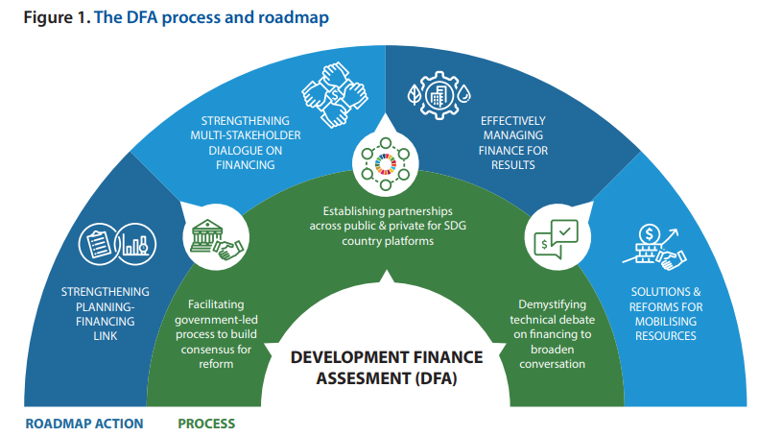

*Figure 16.* Development Finance Assessment process and roadmap

**The Budget Intelligence Toolkit (BIT):** The Budget Intelligence Toolkit (BIT) by the United Nations Economic and Social Commission for Western Asia (UN ESCWA) utilizes machine learning for fiscal incidence analysis on budget expenditures and their impacts on the 17 SDGs and over 100 measurable indicators. It aims to enhance public financial management across planning, spending, delivery, and evaluation stages. By identifying budget allocations positively influencing SDG progress, it aids policymakers in optimizing public spending. The BIT was piloted in Egypt, revealing numerous direct and indirect links between government expenditures and SDG performance, indicating the country's potential for SDG progress through its spending patterns. This tool offers insights to optimize spending efficiency, assess impacts, and align budgets effectively with SDG objectives, partnering with ministries, central banks, and national stakeholders.

**BIT outcomes in Egypt:** In Egypt's fiscal year 2020, over a quarter of the budget supported "people" and "prosperity," with significant allocations to infrastructure, utilities, and economic growth. This allocation strategy notably improved outcomes related to SDGs 3, 4, 6, 7, and 8, especially in health, education, water, sanitation, energy, and economic growth. On average, 34% of government spending contributed to advancing social protection linked to SDGs 1, 2, 3, 4, and 11.

**Financing the 2030 Agenda, Guidebook for UNDP Country Offices**: UNDP developed the “An Introductory Guidebook for UNDP Country Offices”. This guidebook provides an overview of current and recent trends in financing for development and explores their implications for the financing of the 2030 Agenda. Then UNDP’s approach for providing country level support on financing for development is also presented. Then is detailed UNDP’s current portfolio of work on financing for development, and information on the tools and services provided, and where to source more information. Finally, the guidebook describes some of the most widely-used financial instruments as well as innovative finance mechanisms and looks at their pros and cons (UNDP, 2018).

**Additional Resources:**

The Case for Long-Term SDG Financing

<https://irp.cdn-website.com/be6d1d56/files/uploaded/the-case-for-long-term-sdg-financing-e3a35f12.pdf>

SUSTAINABLE DEVELOPMENT REPORT 2023 Implementing the SDG Stimulus

<https://s3.amazonaws.com/sustainabledevelopment.report/2023/sustainable-development-report-2023.pdf>

FACILITATING INVESTMENT IN THE SUSTAINABLE DEVELOPMENT GOALS

<https://unctad.org/system/files/official-document/diaepcb2022d3_en.pdf>

FINANCING THE SUSTAINABLE DEVELOPMENT GOALS THE CONTRIBUTIONS OF THE MULTILATERAL DEVELOPMENT BANKS

<https://www.un.org/ohrlls/sites/www.un.org.ohrlls/files/mdb.pdf>

SCALING FINANCE FOR THE SUSTAINABLE DEVELOPMENT GOALS Foreign Direct Investment, Financial Intermediation and Public-Private Partnerships

<https://globalcompact.no/app/uploads/2020/01/Scaling-SDG-Finance.pdf>

**TAKE-HOME MESSAGES**

• Addressing SDG interlinkages requires collective strength, and the evolving UN ecosystem serves as an enabling platform for collaboration. Under the UN-Energy compacts, coalitions, alliances, hubs, and public-private partnerships are shaping the landscape, addressing energy's interconnectedness with gender, healthcare, clean cooking, resilience for displaced people, green economy, and digital finance services. Joint programs and inter-agency initiatives exemplify innovative solutions, serving as sources of inspiration, while multi-stakeholder knowledge and data platforms promote experiences sharing.

• Building and managing effective multi-stakeholder partnerships for SDG progress involves embracing the dynamic partnership lifecycle, understanding stakeholders, maximizing partnership value, and operating under institutional readiness. Developing effective and transformative joint programs, attractive for investment, necessitate catalyzing policy changes, government ownership, aligned roles and responsibilities, quality standards, and joint management for results.

• Joint funds, investing networks, partnership funds are shaping the financial landscape explicitly to address SDG interlinkages. Innovative financial schemes are arising to be leveraged, such as blended finance and impact investing, with digital intelligence playing a key role. Financing frameworks, platforms, and tools are emerging to facilitate the match between bankable projects and transition and climate finances.

## Module Warp-Up

### Main take-home messages

1. Amplify your critical thinking skills to advance the Energy and Sustainable Development Nexus

Access to electricity and clean cooking acts as a catalyst for achieving multiple SDGs, necessitating a focus on energy affordability and sufficiency, sustainable battery management, and inclusive, gender-responsive approaches. Renewable energies contribute to sustainable prosperity, requiring a holistic approach to manage trade-offs, address water security challenges, and ensure governance. Energy efficiency is pivotal for catalyzing sustainability but demands attention to avoid development degrowth, mitigate large-scale impacts, engage society through capacity-building, and reduce inequalities through digitalization.

1. Leverage strategic approaches and tools for maximizing impact across multiple SDGs

Four approaches revolutionize project design and implementation by adopting a systemic perspective, gender mainstreaming, human rights-based principles, and a portfolio approach for interconnected interventions. Operationalizing nexus projects relies on critical tools such as water-energy-food nexus methods, life cycle assessments, multi-criteria tools, scenario thinking, theory of change, and digital intelligence for informed, data-driven decisions.

1. Unlock opportunities in the dynamic landscape of partnerships and financial structures

Addressing SDG interlinkages involves collective strength, a synergy achievable by harnessing the newly emerging nexus-specific UN ecosystem, emphasizing partnerships, compacts, and alliances. Effective multi-stakeholder partnerships demand understanding stakeholders, maximizing value, and embracing institutional readiness. Financially, the landscape is evolving with emerging nexus-oriented joint funds, investing networks, and partnership funds, complemented by innovative financial mechanisms and digital intelligence. Financing frameworks, platforms, and tools are also emerging to facilitate the alignment between bankable projects and transition and climate finances.

### What next?

This module provides the essential ingredients to craft the right recipe for impactful change. Now that you've delved into the intricate interaction between SDG7 and other SDGs, understanding their synergies, and trade-offs, it's time to apply this knowledge practically. Explore the methods and tools available to ensure their consideration throughout the project cycle. Developing transformative and multi-objective solutions becomes straightforward with the right tools. Find the ones that align with your ambitions.

Addressing the Energy and Sustainable Energy Nexus interlinkages is a collaborative endeavor, with partnerships and collective action as major driving forces. Find allies to multiply your strengths. Remember that effective relationship-building requires strategic actions. Follow the updated guidelines in these matters.

The collaborative financial ecosystem offers a diverse array of solutions tailored to all needs. Specific funds are on the rise to address the SDG nexus, presenting the best solution to optimize finance for meeting the 2023 targets. Importantly, document your experiences to enhance the learning of others. Your example can serve as a valuable guide for those embarking on a similar journey.

### References

*[All references are cited as comments]*